International Day

Hawaii Calls | UF
Hukilau | H10
Island Style C | H12C
Little Grass Shack/Little Brown Gal | UF
Pearly Shells G | H22
Hawaiian Suppa’man | H52

Hawaii Calls (Harry Owens)
Vamp: D7 G7 C (2x)

C Dm G7 C
Hawai`i calls, with a melody of love, dear
Dm G7 C C7
Across the sea as evening falls
F G7 C
The surf is booming on the sand at Waikîkî tonight
D7 G7
And how I wish that you were strolling hand in hand with me tonight
Dm G7 C
Hawai`i calls, with a message of aloha
Dm G7 C C7
To you sweetheart where 'er you are
F Fm C A7
Reminding you to dream awhile of happy days we knew
Dm G7 C
Hawai`i calls and my heart's calling too

(Repeat entire song)
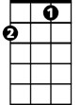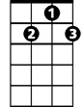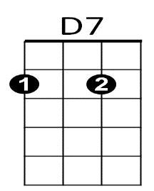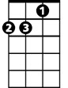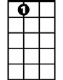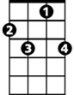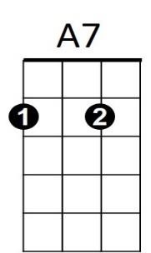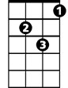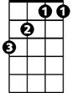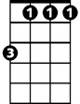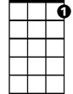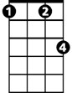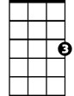

BARITONE

F

G7

Dm

A7

C7

Dm

F

Fm

G7

D7

C

C7

Fm

C



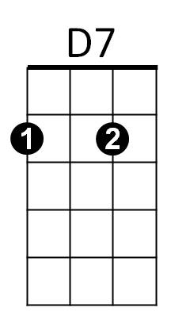

Hukilau
G7
F
C7
H10
VAMP: G7 C7 F (2x)

F
Oh, we’re going to a hukilau
C7
A huki huki huki huki hukilau

Everybody loves the hukilau

Where the laulau is the kaukau
F
At the big luau
D7
We throw our nets out into the sea
G7
And all the ‘ama ‘ama come

A-swimming to me
F D7
Oh, we’re going to a hukilau
C7 F
A huki huki huki hukilau
Hukilau: Community fishing event
Laulau: Hawaiian dish, pork and fish with taro or luau leaves (like spinach or turnip greens) wrapped in ti leaves and steamed
Kaukau: Generic term for food
Luau: Feast
‘Ama ‘ama: Striped mullet
La’ie Bay: Beach site on Northern Oahu near Mala’ekahana State Recreation Area

F
What a beautiful day for fishing
C7
The old Hawaiian way

Where the hukilau nets are swishing
G7 C7
Down in old La’ie Bay

F
Oh, we’re going to a hukilau
C7
BARITONE
A huki huki huki huki hukilau

Everybody loves the hukilau

Where the laulau is the kaukau
F
At the big luau

D7
We throw our nets out into the sea
G7
And all the ‘ama ‘ama come

A-swimming to me
F D7
Oh, we’re going to a hukilau
C7
A huki huki huki huki

Huki huki huki huki
F
Huki huki huki hukilau

VAMP: G7 C7 F (2x)

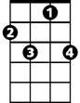

D7
C7
F
G7

Island Style (John Cruz)
H12C

Intro: G D7 G G7 (Melody of second line of chorus)

Chorus:

C G
On the island, we do it island style
D7 G G7
From the mountain to the ocean from the windward to the leeward side
C G
On the island, we do it island style
D7 G
From the mountain to the ocean from the windward to the leeward side


G
C
G7
G C G
Mama's in the kitchen cooking dinner real nice
D7 G
Beef stew on the stove, lomi salmon with the ice
C G
We eat and drink and we sing all day
D7 G G7
Kanikapila in the old Hawaiian way

(Chorus)
BARITONE
C
D7
G
G7
G C G
We go grandma's house on the weekend clean yard, ‘cause
D7 G
If we no go, grandma gotta work hard
G C G
You know my grandma, she like the poi real sour
D7 G G7
I love my grandma every minute, every hour

(Chorus, First Verse and Chorus)

Ending:
Revised 12 July 2016
C G
On the island, we do it island style
D7 G
(repeat 2x) From the mountain to the ocean from the windward to the leeward side

Little Grass Shack / Little Brown Gal *
VAMP: G7 C7 F (2x)
Kay-ah-la-kay-koo-ah
F D7 G7
I want to go back to my little grass shack in Kealakekua, Hawaii
Kah-nays
Vah-hee-nays
C7 F
I want to be with all the kanes and wahines that I used to know, long ago
Ho-oh-now-now
A7 D7
I can hear the old guitars playing on the beach at Ho’o-Nau-Nau
G7 C7
I can hear the old Hawaiians saying "Ko-Mo-Mai No Ka-ua Ika Hale Welakahao"
F D7 G7
It won't be long til my ship will be sailing back to Kona
C7 A7
A grand old place that's always fair to see, you're telling me

D7
I'm just a little Hawaiian, a homesick Island boy
G7
I want to go back to my fish and poi
F D7 G7
I want to go back to my little grass shack in Kealakekua, Hawaii
G7
C7 F
Hoo-moo-hoo-moo-nu-ku-nu-ku-ah-poo-ah-ah
Where the Humu humu nuku nuku a pua’a goes swimming by
C7 F
Where the Humu humu nuku nuku a pua’a goes swimming by
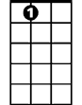
VAMP: G7 C7 F (2x)
C7
A7
F
C7
It’s not the Islands fair that are calling to me
F

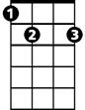
It’s not the balmy air, not the tropical sea
Am
E7
D7 G7
But it’s a little brown gal, in a little grass skirt
C7 F
In a little grass shack in Hawaii

C7
Kah-meha-meha’s Pah-lee
It isn’t Waikiki or Kamehameha’s Pali
Ho-oh-mali-mali
F
Not the beach boys free, with their ho’o mali mali
D7 G7
It’s a little brown gal, in a little grass skirt
BARITONE
C7 F
F
C7
G7
In a little grass shack in Hawaii

Refrain:

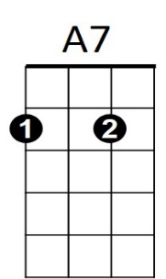
Am E7
Am
Through that Island wonderland
D7
Am E7
She’s broken all the kane’s hearts
Am E7
It’s not hard to understand
Am C7
E7
For that wahine is a gal of parts

C7
I’ll be leaving soon, but the thrill I’ll enjoy
F
Is not the Island moon nor the fish and the poi
D7 G7
It’s just a little brown gal, in a little grass skirt
C7 F
In a little grass shack in Hawaii
D7 G7
It’s just a little brown gal, in a little grass skirt
C7 F
In a little grass shack in Hawaii
VAMP: G7 C7 F
C7 F (2x)
That’s where the Humu humu nuku nuku a pua’a goes swimming by
VAMP: G7 C7 F

Pearly Shells (Ray Coniff) Key G
H22G
Chorus:


G
G7
A7
D
C
G
Pearly Shells (pearly shells)

From the ocean (from the ocean)
C
Shining in the sun (shining in the sun)
D D7
Covering the shore (covering the shore)
G G7
When I see them (when I see them)
C
My heart tells me that I love you
G D7 G F G
More than all those lit-tle pearly shells

D7
For every grain of sand upon the beach
G
BARITONE
I’ve got a kiss for you and
G
C
D7
I’ve got more left over for each star
A7 D7
That twinkles in the blue

(Chorus)
D
D7

Ending:
G D7 G C G
G7
More than all those lit-tle pearly shells

Hawaiian Sup'pa Man (Israel Kamakawiwo'ole)
H52

Intro: Last line of chorus melody: Am G F E7
Am
Oh, tall is the tale of the mischievous one
G
Am
G F E7 Am
Who fished out all the islands and captured the sun
Am
His deeds and tasks I will unmask so that you'll understand
G F E7 Am
That before there was a Clark Kent there was a Hawaiian Superman
E7
F
C G F
He fished out all the islands with a magic hook
C G Am
There would've been more but somebody looked
C G F
He pulled morning sky, the sun he entwined
C G Am E7
C
To slow down his flight, so kapa could dry, yeah

Chorus:
Am
Mischievous, marvelous, magical Maui, Hero of this land
G F E7 Am
The one, the only, the ultimate Hawaiian Supa’man
Am G F E7
Maui, Maui, oh Maui, Hawaiian Supa’man
Am G F E7
BARITONE
Am
G
Maui, Maui, oh Maui, Hawaiian Supa’man
Am
The secret of fire was locked somewhere in time
G F E7 Am
So when the ahi died in the hale kuke, no way to re-ignite
Am
So off he goes in search of those who hold the informa-tion
E7
F
G F E7 Am
So that fire could be used by all the future generations

C G F
He found that Alae held the fire connection
C G Am
But his plan of deception fell short of perfection
C
C G F
With no other choice he had to get mean
C G Am E7
So he squeezed Alae's throat until she screamed the se-cret
(Chorus)
Am G F E7 (2x end in Am)
Maui, Maui, oh Maui, Hawaiian Supa’man

