

50 Ways to Leave Your Lover (Paul Simon)
G
Am

Am G F7
"The problem is all inside your head",
E7
She said to me,
Am G F E7
The answer is easy if you take it logically.
Am G F7 E7
I'd like to help you in your struggle to be free.
Am Dm Am
There must be - fifty ways to leave your lover."

Am G F7 E7
She said: "It's really not my habit to intrude,
Am G
Furthermore I hope my meaning won't be
F E7
Lost or mis-construed,
Am G F7 E7
But I'll repeat myself, at the risk of being crude.
Am Dm Am
There must be - fifty ways to leave your lover."
Dm Am
Fifty ways to leave your lover."

Chorus:
C
Just slip out the back Jack,
Eb
Make a new plan Stan,
F7 C
No need to be coy Roy, just get yourself free
C
Hop on the bus Gus,
Eb
You don't need to discuss much,
F7 C
Just drop off the key Lee, and get yourself free.

C Eb
Slip out the back Jack, make a new plan Stan,
F7
You don't need to be coy Roy,
C

you just listen to me.
F
C
Hop on the bus Gus,
Eb
You don't need to discuss much,
F7 C
Just drop off the key Lee, and get yourself free.
Am G
She said: "It grieves me so
F7 E7
To see you in such pain.
Am G
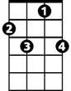
I wish there was something I could do
F7
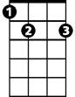
F E7
E7
To make you smile again."
Am G
I said: "I appreciate that
F7 E7
And would you please explain

Am Dm Am
F
About the - fifty ways."

Am G
She said: "Why don't we both just
F7 E7
Sleep on it tonight,
Am G

And I believe that in the morning
Dm
F E7
You'll begin to see the light."
Am G
Then she kissed me and I realized,
F7 E7
She probably was right,
Am Dm Am

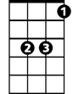
There must be fifty ways to leave your lover,
C
Eb
Dm Am
Fifty ways to leave your lover.

(Chorus)

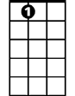
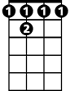
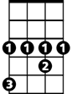
E7
F 7
G
Am
C
Eb
BARITONE


Dm


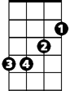
50 Ways to Leave Your Lover (Paul Simon)
D
Em

Em D C7
"The problem is all inside your head",
B7
She said to me,
Em D C B7
The answer is easy if you take it logically.
Em D C7 B7
I'd like to help you in your struggle to be free.
Em Am Em
There must be - fifty ways to leave your lover."

Em D C7 B7
She said: "It's really not my habit to intrude,
Em D
Furthermore I hope my meaning won't be
C E7
Lost or mis-construed,
Em D C7 B7
But I'll repeat myself, at the risk of being crude.
Em Am Em
There must be - fifty ways to leave your lover."
Am Em
Fifty ways to leave your lover."

Chorus:
G
Just slip out th e back Jack,
Bb
Make a new plan Stan,
C7 G
No need to be coy Roy, just get yourself free
G
Hop on the bus Gus,
Bb
You don't need to discuss much,
C7 G
Just drop off the key Lee, and get yourself free.
BARITONE

G Bb
Slip out the back Jack, make a new plan Stan,
C7
You don't need to be coy Roy,
G
G
You just listen to me.
C
Am
G
Hop on the bus Gus,
Bb
You don't need to discuss much,
C7 G
Just drop off the key Lee, and get yourself free.
Em D
She said: "It grieves me so
C7 B7
To see you in such pain.
Em D
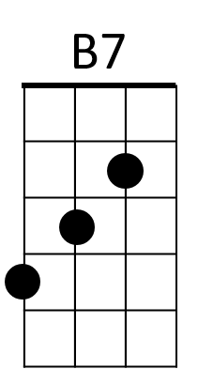

I wish there was something I could do
C7
C B7
To make you smile again."
Em D
I said: "I appreciate that
C7 B7
And would you please explain
Em Am Em
C
About the - fifty wa -ys."

Em D
She said: "Why don't we both just
C7 B7
Sleep on it tonight,
Em D
Am
And I believe that in the morning
C B7
You'll begin to see the light."
Em D
Then she kissed me and I realized,
C7 B7
She probably was right,
Em Am Em
There must be - fifty ways to leave your lover."
Am Em
G
Bb
Fifty ways to leave your lover.

(Chorus)
Bb
E7
C7
D
Em

