A Hard Day’s Night (Lennon/McCartney) Key C
Intro: C7sus4 (break)

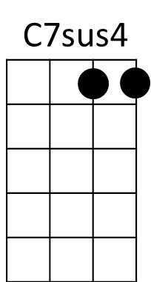
C F C
It's been a hard day's night
Bb C
And I've been working like a dog.

C F C
C
It's been a hard day's night
Bb C
I should be sleeping like a log.
F
But w hen I get home to you


G
F
Bb
I find the things that you do
C F C
Will make me feel all right.

F C

You know I work all day
G
Bb C
To get you money to buy you things
F C
And it's worth it just to hear you say
Bb C
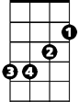
You're gonna give me everything
Em
F
So why on earth should I moan
G

'Cause when I get you alone
Am
C F C

You know I'll feel O .K.
C7

Bridge:
Em
When I'm home
Am Em
Everything seems to be right
C
When I'm home
Am Bb G
Feeling you holding me tight, tight yeah!!

(First Verse)

(Instrumental)
C F C
You know I work all day
Bb C
To get you money to buy you things
F C
And it's worth it just to hear you say
Bb C
You're gonna give me everything
F
So why on earth should I moan
G
'Cause when I get you alone
C F C
You know I'll feel O .K.

(Bridge)

(First Verse)

F C F C
You know I feel all right
F C C7 C7sus4 C
You know I feel all right.
BARITONE

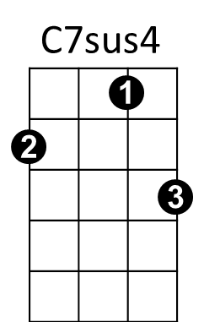
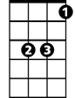
C
Bb
F

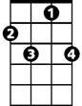

C7
Em
Am
G

A Hard Day’s Night (Lennon/McCartney) Key G
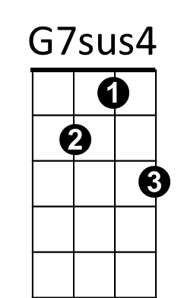
Intro: G7sus4 (break)

G C G
It's been a hard d ay's night
F G
And I've been working like a dog.
G C G
G
It's been a hard day's night
F G
I should be sleeping like a log.
C
But w hen I get home to you
D
C
F
I find th e things that you do
G C G
Will make me feel all right.

C G

You know I work all day
D
F G
To get you money to buy you things
C G
And it's worth it just to hear you say
F G
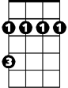
You're gonna give me everything
Bm
C
So why on earth should I moan
D
'Cause when I get you alone
Em
G C G

You know I'll feel O .K.
G7

Bridge:
Bm
When I'm home
Em Bm
Everything seems to be right
G
When I'm home
Em F D
Feeling you holding me tight, tight yeah!!

(First Verse)

(Instrumental)
G C G
You know I work all day
F G
To get you money to buy you things
C G
And it's worth it just to hear you say
F G
You're gonna give me everything
C
So why on earth should I moan
D
'Cause when I get you alone
G C G
You know I'll feel O .K.

(Bridge)

(First Verse)

C G C G
You know I feel all right
C G G7 G7sus4
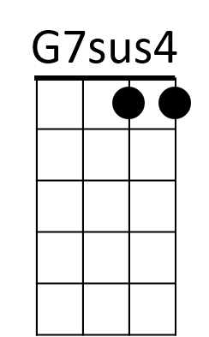
You know I fee all right.
G
C
F
D
Bm
Em
G7
BARITONE

