A Holly Jolly Christmas
C09B
by Johnny Marks

C Cmaj7 C6 C Cmaj7 G7
Have a holly, jolly Christmas, it's the best time of the year,
C
I don't know if there'll be snow, but have a cup of cheer.
C Cmaj7 C6 C Cmaj7 G7
Have a holly, jolly Christmas, and when you walk down the street,
C C7
Say hello to friends you know and everyone you meet.

F Em F C
Hey, ho, the mistletoe, hung where you can see,
Dm Am D7 Am D7 G G7
Somebody's waiting there, kiss her once for me.

C Cmaj7 C6 C Cmaj7 G7
Have a holly, jolly Christmas and in case you didn't hear,
C D7 G7 C
Oh, by golly, have a holly, jolly Christmas this year.

Repeat From Top
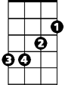


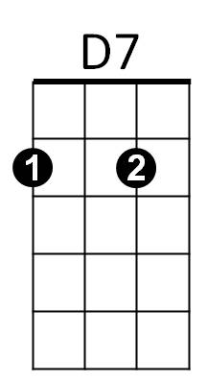




Em
Am
Dm
C7
G7
F
C

BARITONE


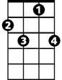
D7
Am
Em
Dm
C
F
G7
C7

