A Hundred Pounds of Clay (Bob Elgin, Luther Dixon and Kay Roger) 1961 Key G
Intro: G Em Am D7

G Em
He took a hundred pounds of clay
Am D7
And then He said "Hey, listen"
G Em
"I'm gonna fix this-a world today"
Am D7
"Because I know what's missin' "
C D7
Then He rolled his big sleeves up
C D7
And a brand-new world began
G Em
He created a woman and -
Am D7 G
Lots of lovin' for a man
Em C D7
Whoa-oh-oh, yes he did

G Em
With just a hundred pounds of clay
Am D7
He made my life worth livin'
G Em
And I will thank Him every day
Am D7
For every kiss you're givin'
C D7
And I'll thank Him every night
C D7
For the arms that are holdin' me tight
G Em
And He did it all with
Am D7 G
Just a hundred pounds of clay
C G D7
Yes he did, whoa-oh, yes He did

G
Now can'tcha just see Him a-walkin'
G#dim
'round and 'round
Am D7
Pickin' the clay up off of the ground?
G G#dim
Doin' just what He should do
Am D7
To make a livin' dream like you

C D7
He rolled his big sleeves up
C D7
And a brand-new world began
G Em
He created a woman and -
Am D7 G
Lots of lovin' for a man
Em C
Whoa-oh-oh, yes he did
D7 G
With just a hundred pounds of clay

Em C
People, let me tall ya what He did
D7 G
With just a hundred pounds of clay

G Em Am D7 C D Am G

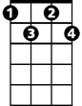

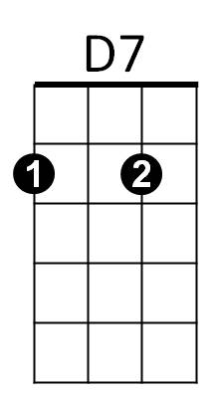
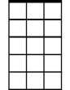

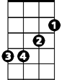
G#dim
C
Am7
G
Em


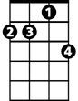
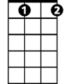


G
BARITONE
Em
Am7
G#dim
C
D7

A Hundred Pounds of Clay (Bob Elgin, Luther Dixon and Kay Roger) 1961 Key C
Intro: C Am Dm G7

C Am
He took a hundred pounds of clay
Dm G7
And then He said "Hey, listen"
C Am
"I'm gonna fix this-a world today"
Dm G7
"Because I know what's missin' "
F G7
Then He rolled his big sleeves up
F G7
And a brand-new world began
C Am
He created a woman and -
Dm G7 C
Lots of lovin' for a man
Am F G7
Whoa-oh-oh, yes he did

C Am
With just a hundred pounds of clay
Dm G7
He made my life worth livin'
C Am
And I will thank Him every day
Dm G7
For every kiss you're givin'
F G7
And I'll thank Him every night
F G7
For the arms that are holdin' me tight
C Am
And He did it all with
Dm G7 C
Just a hundred pounds of clay
F C G7
Yes he did, whoa-oh, yes He did

C
Now can'tcha just see Him a-walkin'
C#dim
'round and 'round
Dm G7
Pickin' the clay up off of the ground?
C C#dim
Doin' just what He should do
Dm G7
To make a livin' dream like you

F G7
He rolled his big sleeves up
F G7
And a brand-new world began
C Am
He created a woman and -
Dm G7 C
Lots of lovin' for a man
Am F
Whoa-oh-oh, yes he did
G7 C
With just a hundred pounds of clay

Am F
People, let me tell ya what He did
G7 C
With just a hundred pounds of clay

C Am Dm G7 F G Dm C


C#dim
F
C
Am
Dm
G7


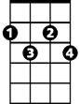


G7
C#dim
F
C
Am
Dm
BARITONE

