A Kind Of Hush (Geoff Stephens / Les Reed)


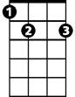

Intro: C G7 C G7
G7
Am
E7
C
C E7 Am C7
There's a kind of hush all over the world to-night
F G7
All over the world you can hear the sounds
C G


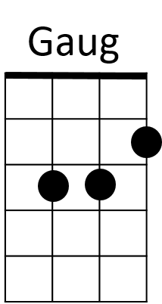
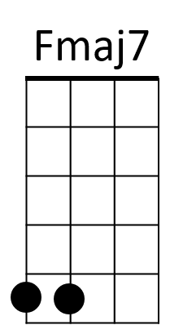
Of lovers in love you know what I mean
F
C7
C E7 Am C7
Just the two of us and nobody else in sight
F G7
There's nobody else and I'm feeling good
C C7
Just holding you tight

Chorus:
F Dm
So listen very carefully
Fmaj7 Dm C C7
Closer now and you will see what I mean - It isn't a dream
F Dm
The only sound that you will hear
Fmaj7 Dm G
Is when I whisper in your ear I love you
Gaug
For ever and ever

C E7 Am C7
There's a kind of hush all over the world to-night
F G7 C
All over the world you can hear the sounds of lovers in love


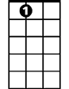
C E7 Am C7
C
Am
G7
E7
BARITONE
La la la la la laaaa la la la la la la la la laaaaaa
F G7 C C7
La la la la laaa la la la la laaaa la la la laaaa

(Chorus)

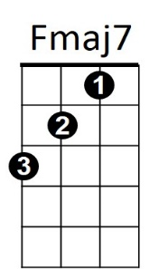
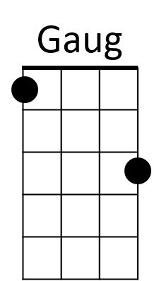

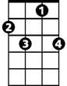
C E7 Am C7
F
C7
There's a kind of hush all over the world to-night
F G7
All over the world people just like us
C G7 C G7
Are falling in love - are falling in love
C G7 (PAUSE)
They're falling in love
C
They’re falling in love

