A Love Song (Kenny Loggins/Donna Lyn George)
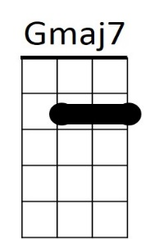


Am
G
Intro: G Gmaj7 Am D Am D G

G Em7
There's a wren in a willow wood, flies so high, sings so good,
Am D Am D
And he brings to you - what he sings to you.
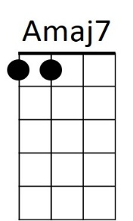

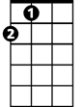
G Gmaj7
D
A
And the love in his lullaby seemed to tell me if I try
Am D Am D
I could fly for you, and lover I want to try for you 'cause

CHORUS:

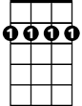
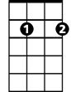
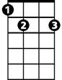
G Gmaj7 Am D
Bm7
Em7
E7
I want to sing you a love song
Am D G
I want to rock you in my arms all night long.
Gmaj7 Am D Am
I want to get to know you, I want to show you
D G
The peaceful feeling of my home.

G Em7
Summer thunder on moon bright days, northern lights and skies ablaze
Am D Am D
BARITONE
I'll bring to you, if you'll let me sing to you.

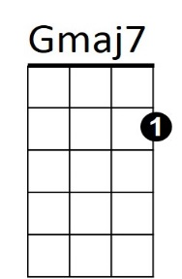

G Gmaj7
G
Am
Silver wings in a fiery sky show the trail of our love
Am D Am D
And I'll sing to you, love is what I bring to you
Am D
I want to sing to you. Oh,
D
A
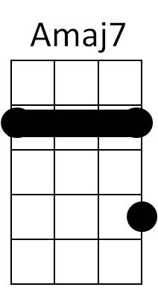
(CHORUS)

Bm7 Em7

A Amaj7 Bm7 E7 / Bm7 Em7 A

A Amaj7 Bm7 E7
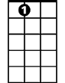
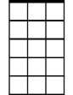
I want to sing you a love song
Bm7
E7
Em7
Bm7 E7 A
I want to rock you in my arms all night long.
Amaj7 Bm7 E7 Bm7
I want to get to know you, I want to show you
Em7 A
The peaceful feeling of my home.
A Amaj7 Bm7 E7 / Bm7 E7 A / Bm7 E7 / Bm7 E7 A

