A Lover’s Concerto (1965) (C)
Lyrics by Sandy Linzer & Denny Randell, 1965
Music: “Minuet in G Major" by Christian Petzold (1677-1733) (erroneous attributed to J.S. Bach)
A Lover’s Concerto by The Toys (1965)

Intro (4 Measures): First four lines.

C Em  How gentle is the rain  F G C Am  That falls softly on the mea-dow,  Dm G C  Birds high up the trees  Am G C Dm G7  Serenade the clouds with their melo-dies. Oh,  C Em  See there beyond the hill,  F G C Am  The bright colors of the rain-bow.  Dm G C  Some magic from a-bove  Am Dm G C G  Made this day for us just to fall in love.  C Em  Now, I belong to you  F G C Am  From this day until for-ever,  Dm G C  Just love me tender-ly  Am G C Dm G7  And I'll give to you every part of me. Oh, |  |  |  |  | C Em  Don't ever make me cry  F G C Am  Through long lonely nights with out us.  Dm G C  Be always true to me,  Am Dm G C G  Keep this day in your heart eternal-ly.  Instrumental Chorus (“Oh, don’t ever…”)  C Em  One day we shall re-turn  F G C Am  To this place upon the mea-dow.  Dm G C  We'll walk out in the rain,  Am G C Dm  See the birds above singing once a-gain.  (Repeat 2x then Instrumental 1x)  G7 C Em  Oh, You hold me in your arms,  F G C Am  And say once again you love me,  Dm G C  And if your love is true,  Am Dm G C  Everything will be just as wonder-ful.
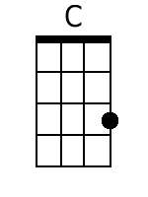 | 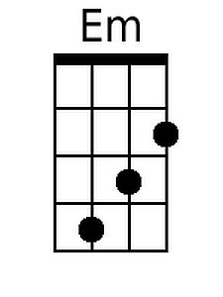 | 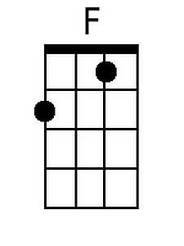 | 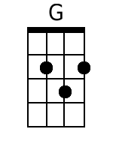 | 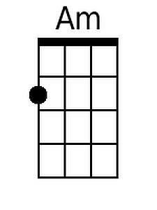 |  | 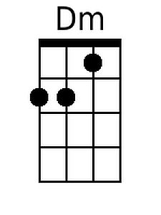 | 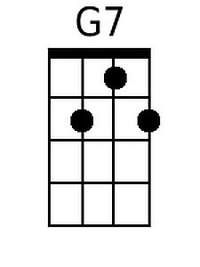
Baritone
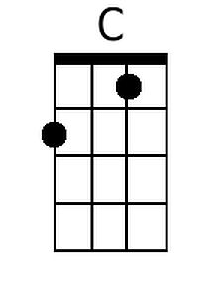 | 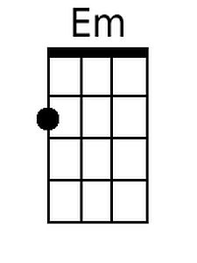 | 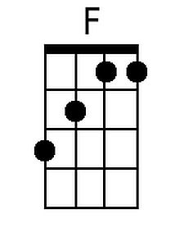 | 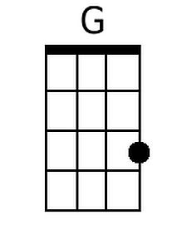 | 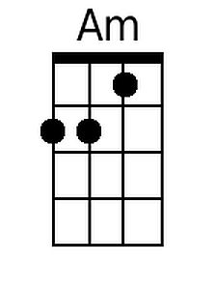 |  | 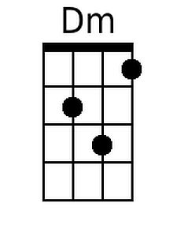 | 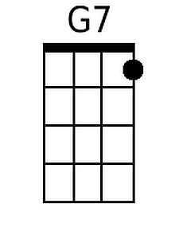

A Lover’s Concerto (1965) (G)
Lyrics by Sandy Linzer & Denny Randell, 1965
Music: “Minuet in G Major" by Christian Petzold (1677-1733) (erroneous attributed to J.S. Bach)
A Lover’s Concerto by The Toys (1965)

Intro (4 Measures): First four lines.

G Bm  How gentle is the rain  C D G Em  That falls softly on the mea-dow,  Am D G  Birds high up the trees  Em D G Am D7  Serenade the clouds with their melo-dies. Oh,  G Bm  See there beyond the hill,  C D G Em  The bright colors of the rain-bow.  Am D G  Some magic from a-bove  Em Am D G D  Made this day for us just to fall in love.  G Bm  Now, I belong to you  C D G Em  From this day until for-ever,  Am D G  Just love me tender-ly  Em D G Am D7  And I'll give to you every part of me. Oh, |  |  |  |  | G Bm  Don't ever make me cry  C D G Em  Through long lonely nights with out us.  Am D G  Be always true to me,  Em Am D G D  Keep this day in your heart eternal-ly.  Instrumental Chorus (“Oh, don’t ever…”)  G Bm  One day we shall re-turn  C D G Em  To this place upon the mea-dow.  Am D G  We'll walk out in the rain,  Em D G Am  See the birds above singing once a-gain  (Repeat 2x then Instrumental 1x)  D7 G Bm  Oh, you hold me in your arms,  C D G Em  And say once again you love me,  Am D G  And if your love is true,  Em Am D G  Everything will be just as wonder-ful.
 | 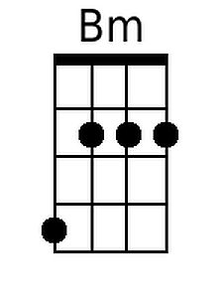 |  | 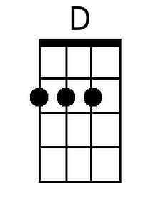 |  |  |  | 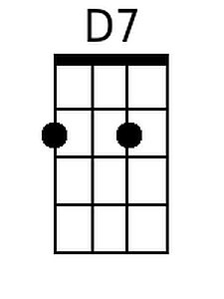
Baritone
 | 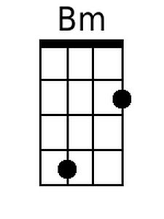 |  | 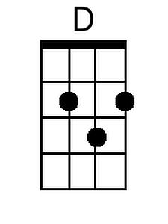 |  |  |  | 