


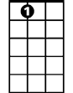
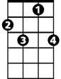



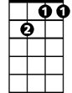
A World Without Love (John Lennon / Paul McCartney)
F
Bb
Dm
A7
F7
C
Gm
C7
Gm7
Intro: F Gm7 C7 F (last 2 lines of verse) G# // Bb // F/
F A7 Dm
Please lock me away and don't allow the day
F Bb F
Here inside, where I hide with my loneliness
Gm7
I don't care what they say
C7 F C C7
I won't stay in a world without love

F A7 Dm
Birds sing out of tune and rain clouds hide the moon
F Bb F
I'm okay, here I stay with my loneliness
Gm7
I don't care what they say
C7 F F7
I won't stay in a world without love

Reprise:
Gm F
So I wait and in a while, I will see my true love smile
Gm
She may come, I know not when
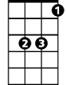
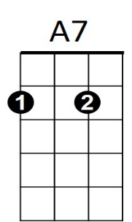
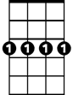
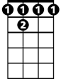
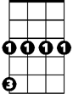
Gm7 C C7 F
Bb
Gm7
C7
F
Dm
F 7
BARITONE
Gm
C
When she does, I'll lose ~ So baby, until then…

F A7 Dm
Lock me away and don't allow the day
F Bb F
Here inside, where I hide with my loneliness
Gm7
I don't care what they say
C7 F F7
I won't stay in a world without love
(Reprise)

(Instrumental First two lines of first verse)

Gm7
I don't care what they say
C7 F Dm
I won't stay in a world without love
Gm7
I don't care what they say
C7 F
I won't stay in a world without love

Ending: Same as Intro

