Abracadabra (Steve Miller)

Am Dm
I heat up, I can’t cool down
E7 Am
You got me spinnin, round and round
Am Dm
Round and round and round it goes
E7 Am
Where it stops nobody knows

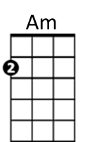
Am Dm
Every time you call my name
E7 Am
I heat up like a burnin flame
Am Dm
Burnin flame full of desire
E7
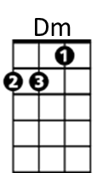
Kiss me baby, let the fire get higher

Chorus:
Am Dm
Abra-abra-cadabra
E7 Am
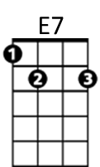
I want to reach out and grab ya
Am Dm
Abra-abra-cadabra
E7 Am
Abracadabra

Am Dm
You make me hot, you make me sigh
E7 Am
You make me laugh, you make me cry
Am Dm
Keep me burnin’ for your love
E7 Am
With the touch of a velvet glove


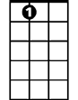
Dm
BARITONE
Am
E7
(Chorus)

Am Dm
I feel the magic in your caress
E7 Am
I feel magic when I touch your dress
Am Dm
Silk and satin, leather and lace
E7 Dm
Black panties with an angels face

Am Dm
I see magic in your eyes
E7 Am
I hear the magic in your sighs
Am Dm
Just when I think I’m gonna get away
E7 Am
I hear those words that you always say

(Chorus)

Am Dm
Every time you call my name
E7 Am
I heat up like a burnin’ flame
Am Dm
Burnin flame full of desire
E7
Kiss me baby, let the fire get higher

Am Dm
I heat up, I can’t cool down
E7 Am
My situation goes round and round
Am Dm
I heat up, I can’t cool down
E7 Am
My situation goes round and round
Am Dm
I heat up, I can’t cool down
E7 Am
My situation goes round and round

