Against the Wind (Bob Seger)
Intro: C Em F C (2x)

C Em
It seems like yesterday, but it was long ago
F C
Janie was lovely, she was the queen of my nights
G F
There in the darkness with the radio playing low.
C Em
The secrets that we shared, the mountains that we moved
F C
Caught like a wild fire out of control
F G
Till there was nothing left to burn and nothing left to prove.

Am G C
And I remember what she said to me
Am F C
How she swore that it never would end
Am G F
I remember how she held me oh so tight,
G
Wish I didn't know now what I didn't know then.

C Em F C
Against the wind, we were running against the wind.
F Em Dm
We were young and strong, we were running …
F C
Against the wind.

C Em
The years rolled slowly past, I found myself alone,
F C
Surrounded by strangers I thought were my friends,
G F
I found myself further and further from my home.
C Em
And I guess I lost my way, there were oh, so many roads.
F C
I was livin' to run and runnin' to live,
F G
Never worrying about paying or how much I owed.

Am G C
Movin' eight miles a minute for months at a time,
Am F C
Breakin' all of the rules I could bend.
Am G C
I began to find myself searching
F G
Searching for shelter again and a gain.

C Em F C
Against the wind, we were running against the wind.
F Em Dm F C
I found myself seeking shelter against the wind.

(Instrumental first verse)

Am G C
All those drifter's days are past me now
Am F C
I've got so much more to think about
Am G F
Deadlines and commitments,
G
What to leave in and what to leave out.

C Em F C
Against the wind, I’m still running against the wind.
F Em G C
Well I'm older now but still running … Against the wind
F Em G F
Well I'm older now but still running … Against the wind
C F
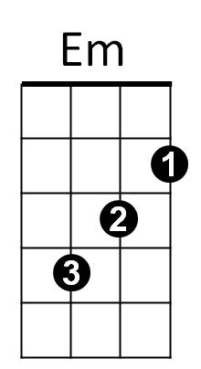
Against the wind …. Against the wind (Repeat to fade)
BARITONE
C
Em
F
G
Am
Dm
C
F
Am
G
Dm

