Against The Wind (Bob Seger) (G)

Intro: G Bm C G (2x)

G Bm  It seems like yesterday, but it was long ago  C G  Janie was lovely, she was the queen of my nights  D C  There in the darkness with the radio playing low.  G Bm  The secrets that we shared, the mountains that we moved  C G  Caught like a wild fire out of control  C D  Till there was nothing left to burn and nothing left to prove.  Em D G  And I remember what she said to me  Em C G  How she swore that it never would end  Em D C  I remember how she held me oh so tight,  D  Wish I didn't know now what I didn't know then.  G Bm C G  Against the wind, we were running against the wind.  C Bm Am  We were young and strong, we were running  C G  Against the wind.  G Bm  The years rolled slowly past, I found myself alone,  C G  Surrounded by strangers I thought were my friends,  D C  I found myself further and further from my home.  G Bm  And I guess I lost my way, there were oh, so many roads.  C G  I was livin' to run and runnin' to live,  C D  Never worrying about paying or how much I owed.  Em D G  Movin' eight miles a minute for months at a time,  Em C G  Breakin' all of the rules I could bend.  Em D G  I began to find myself searching  C D  Searching for shelter again and a gain.  G Bm C G  Against the wind, we were running against the wind.  C Bm Am C G  I found myself seeking shelter against the wind. | (Instrumental first verse)  Em D G  All those drifter's days are past me now  Em C G  I've got so much more to think about  Em D C  Deadlines and commitments,  D  What to leave in and what to leave out.  G Bm C G  Against the wind, I'm still running against the wind.  C Bm D G  Well I'm older now but still running Against the wind  C Bm D C  Well I'm older now but still running Against the wind  G C  Against the wind . Against the wind (Repeat to fade)
 | 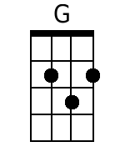 | 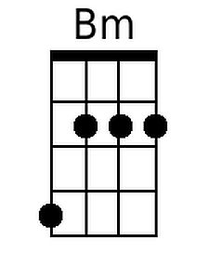 | 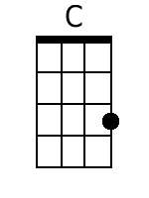
 | 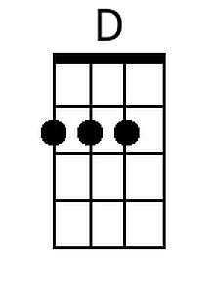 | 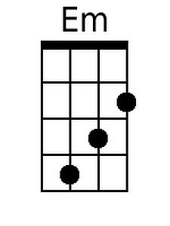 | 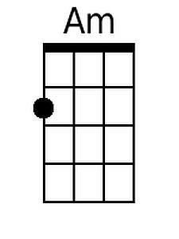
 |  | Baritone
 | 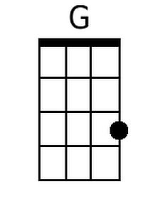 | 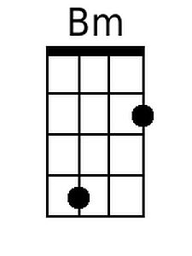 | 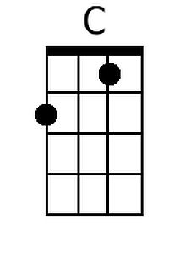
 | 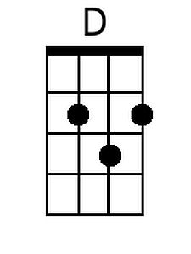 | 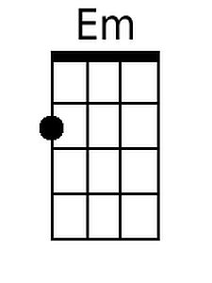 | 