


Ain’t We Got Fun (Richard A Whiting / Raymond B Egan) Key C
C7
C
G7
C G7
Every morning, every evening, ain’t we got fun?
C C7
Not much money, oh but honey, ain’t we got fun?
F C
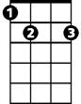
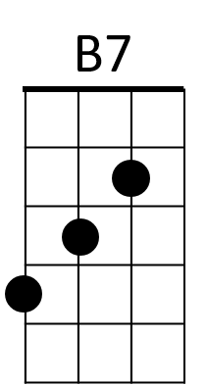
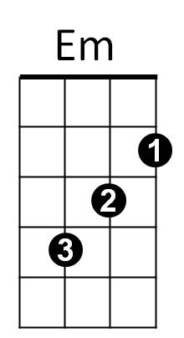
The rent’s unpaid, dear, we haven’t a car
E7
Em B7 Em G7
But any-way dear, we’ll stay as we are

C G7
Even if we owe the grocer, don’t we have fun?



C C7
Dm
Am
F
Tax collector’s getting closer, still we have fun
F E7 Am
There’s nothing sur - er,
Dm B7 C Fm7
The rich get richer and the poor get poorer
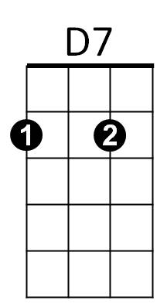
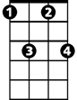
C D7 G7 C
Fm7
In the meantime, in between time ain’t we got fun?

(First Verse)

C G7
Even if we owe the grocer, don’t we have fun?
C C7
Tax collector’s getting closer, still we have fun
F E7 Am
There’s nothing sur - er,
BARITONE
Dm B7 C Fm7
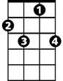
The rich get richer and the poor get children
C7
G7
C
C D9 G7 C
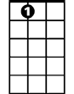
In the meantime, in between time ain’t we got fun?
E7



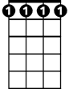
Em
B7
F
Am
Dm
D7
Fm7

Ain’t We Got Fun (Richard A Whiting / Raymond B Egan) Key F
F7
C7
F
F C7
Every morning, every evening, ain’t we got fun?
F F7
Not much money, oh but honey, ain’t we got fun?
F
The rent’s unpaid, dear, we haven’t a car
Bb
Am
E7
Am E7 Am C7
But any-way dear, we’ll stay as we are

F C7
Even if we owe the grocer, don’t we have fun?
F F7
Dm
Gm
A7
Tax collector’s getting closer, still we have fun
Bb A7 Dm
There’s nothing sur - er,
Gm E7 F Bbm7
The rich get richer and the poor get poorer
F G7 C7 F
Bbm7
G7
In the meantime, in between time ain’t we got fun?

(First Verse)

F C7
Even if we owe the grocer, don’t we have fun?
F F7
Tax collector’s getting closer, still we have fun
Bb A7 Dm
There’s nothing sur - er,
BARITONE
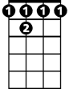
Gm E7 F Bbm7
F
C7
F 7
The rich get richer and the poor get children
F G7 C7 F
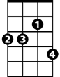
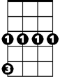
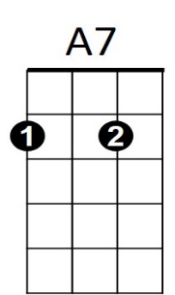
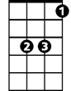
In the meantime, in between time ain’t we got fun?
Bbm7
G7
Am
E7
Gm
Dm
Bb

