All I Have to Do Is Dream (Boudleaux Bryant, 1958) (C)
C Am F G
Dre-eam, dream dream dream
C Am F G
Dre-eam, dream dream dream

C Am F G
When I want you in my arms,
C Am F G
When I want you and all your charms
C Am F G
Whenever I want you, all I have to do, is
C Am F G
Dream, dream dream dream

C Am F G
When I feel blue in the night,
C Am F G
And I need you to hold me tight
C Am F G
Whenever I want you, all I have to do, is
C F C C7
Dreeeeam

Reprise:
F
I can make you mine,
Em
Taste your lips of wine,
Dm G C
Any time, night or day
F Em
Only trouble is, gee whiz,
D7 G
I'm dreamin' my life away

BARITONE





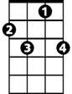


C
F
G
Em
Dm
C7
D7
Am

C Am F G
I need you so that I could die,
C Am F G
I love you so, and that is why
C Am F G
Whenever I want you, all I have to do, is
C Am F G
Dream, dream dream dream,
C F C C7
Dreeeeam

(Reprise)

C Am F G
I need you so that I could die,
C Am F G
I love you so, and that is why
C Am F G
Whenever I want you, all I have to do, is
(repeat 3x to fade)
C Am F G C

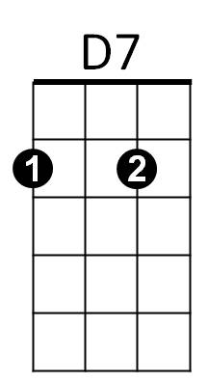
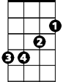

Dre-eam, dream dream dream.
G
F
Am
C
Em
C7
Dm

