All My Exes Live in Texas (Sanger D. Shafer / Linda J. Shafer)

Chorus
G D
All my exes live in Texas
D7 Am G
And Texas is the place I’d dearly love to be
D
But all my exes live in Texas
D7 G
And that’s why I hang my hat in Tennessee

G
Rosanna’s down in Texarkana,
Am
Wanted me to push her broom
D
Sweet Eileen’s in Abilene,
G
She forgot I hung the moon

And Allison’s in Galveston,
Am
somehow lost her sanity
A7
And Dimples, who now lives in Temple,
D
Has got the law looking for me

(Chorus)

G Am
I remember that ol’ Frio River where I learned to swim
D
But it brings to mind another time
G
Where I wore my welcome thin
Am
By Transcendental Meditation I go there each night
A7 D
But I always come back to myself, long before daylight

G D
All my exes live in Texas
D7 Am G
And Texas is the place I’d dearly love to be
D
But all my exes live in Texas
D7 G
Therefore I reside in Tennessee
D
Some folks think I’m hidin’ ~

it’s been rumored that I died
D7 G
But I’m alive and well in Tennessee

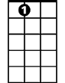

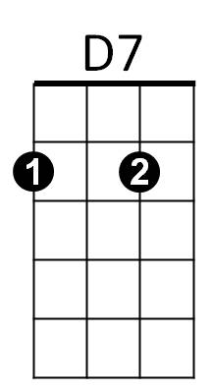


A7
G
D
Am



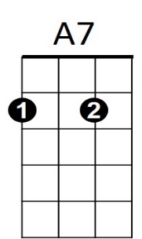

G
D
D7
BARITONE
Am

