Always on My Mind (James Mark / Christopher John Lee Jr) Key of C

C G
Maybe I didn't love you~~
Am C F G C
Quite as often as I could have
G
And maybe I didn't treat you~~
Am C Dm7 F
Quite as good as I should have ~~

F C
If I made you feel second best,
F C Dm G
Girl, I'm sorry I was blind ~~
Am G7 C Dm Em F
But you were always on my mind
G7 C F G
You were always on my mind

C G
Maybe I didn't hold you~~
Am C F G C
All those lonely, lonely times
G
And I guess I never told you~~
Am C Dm7 F
I'm so happy that you're mine ~~

F C F
Little things I should have said and done
C Dm F G
I just never took the time
G7 C F
You were always on my mind~~
G7 C F G
You were always on my mind

C G Am C

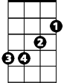

Tell me,
A
Bm
D
F C Dm
Tell me that your sweet love hasn't died
C G Am C
Give me,
F C Dm G
Give me one more chance to keep you satisfied

C G
Maybe I didn't hold you~~
Am C F G C
All those lonely, lonely times
G
And I guess I never told you~~
Am C Dm7 F
I'm so happy that you're mine ~~

F C
Little things I should have said and done
F C Dm F G
I just never took the time
G7 C F
You were always on my mind~~
G7 C F G
You were always on my mind

Am G7 C Dm Em F
But you were always on my mind
G7 C F C
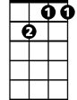





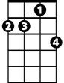



You were always on my mind
Dm7
G7
Dm
C
G
BARITONE
F
Em
Dm7
G7
Dm
C
G
Am
F

Am

Em

Always on My Mind (James Mark / Christopher John Lee Jr) Key of D

D A
Maybe I didn't love you~~
Bm D G A D
Quite as often as I could have
A
And maybe I didn't treat you~~
Bm D Em7 G
Quite as good as I should have ~~

G D
If I made you feel second best,
G D Em A
Girl, I'm sorry I was blind ~~
Bm A7 D Em F#m G
But you were always on my mind
A7 D G A
You were always on my mind

D A
Maybe I didn't hold you~~
Bm D G A D
All those lonely, lonely times
A
And I guess I never told you~~
Bm D Em7 G
I'm so happy that you're mine ~~

G D G
Little things I should have said and done
D Em G A
I just never took the time
A7 D G
You were always on my mind~~
A7 D G A
You were always on my mind

D A Bm D
Tell me,
G D Em
Tell me that your sweet love hasn't died
D A Bm D
Give me,
G D Em A
Give me one more chance to keep you satisfied

D A
Maybe I didn't hold you~~
Bm D G A D
All those lonely, lonely times
A
And I guess I never told you~~
Bm D Em7 G
I'm so happy that you're mine ~~

G D G
Little things I should have said and done
D Em G A
I just never took the time
A7 D G
You were always on my mind~~
A7 D G A
You were always on my mind

Bm A7 D Em F#m G
But you were always on my mind
A7 D G D
You were always on my mind
G
BARITONE
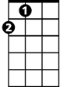
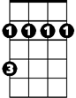
A
D
Bm

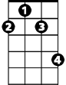
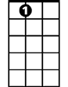
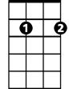
F#m
A7
Em7
Em

A
Bm
G
D

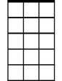
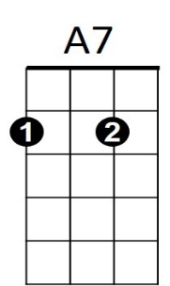
Em7
F#m
Em

Always on My Mind (James Mark / Christopher John Lee Jr) Key of G

G D
Maybe I didn't love you~~
Em G C D G
Quite as often as I could have
D
And maybe I didn't treat you~~
Em G Am7 C
Quite as good as I should have ~~

C G
If I made you feel second best,
C G Am D
Girl, I'm sorry I was blind ~~
Em D7 G Am Bm C
But you were always on my mind
D7 G C D
You were always on my mind

G D
Maybe I didn't hold you~~
Em G C D G
All those lonely, lonely times
D
And I guess I never told you~~
Em G Am7 C
I'm so happy that you're mine ~~

C G C
Little things I should have said and done
G Am C D
I just never took the time
D7 G C
You were always on my mind~~
D7 G C D
You were always on my mind

G D Em G
Tell me,
C G Am
Tell me that your sweet love hasn't died
G D Em G
Give me,
C G Am D
Give me one more chance to keep you satisfied

G D
Maybe I didn't hold you~~
Em G C D G
All those lonely, lonely times
D
And I guess I never told you~~
Em G Am7 C
I'm so happy that you're mine ~~

C G C
Little things I should have said and done
G Am C D
I just never took the time
D7 G C
You were always on my mind~~
D7 G C D
You were always on my mind

Em D7 G Am Bm C
But you were always on my mind
D7 G C G
You were always on my mind
C
Em
D
G

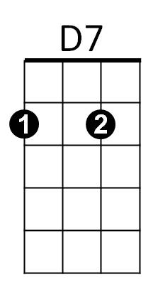
Am
Bm
Am7

BARITONE
C
Em
G
D

Am7
D7
Am
Bm

