Amazing Grace
Lyrics: John Newton (1772), First Published in Olney Hymns (1779)
Music: "New Britain" (Traditional) in William Walker, ed., Southern Harmony, p. 8 (1847)

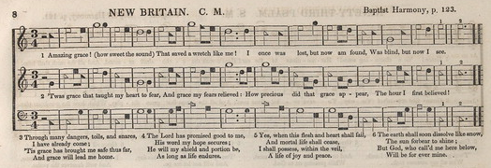
Amazing Grace (John Newton, 1772) (C)

Intro: Last 2 lines of Verse  C F C  A-mazing Grace, how sweet the sound,  G7  That saved a wretch like me.  C F C  I once was lost but now am found,  G7 C  Was blind, but now I see.  C F C  T'was Grace that taught my heart to fear.  G7  And Grace, my fears relieved.  C F C  How precious did that Grace appear  G7 C  The hour I first believed.  C F C  Through many dangers, toils and snares  G7  I have already come;  C F C  'Tis Grace that brought me safe thus far  G7 C  and Grace will lead me home. |  |  |  | C F C  The Lord has promised good to me.  G7  His word my hope secures.  C F C  He will my shield and portion be,  G7 C  As long as life endures.  C F C  Yea, when this flesh and heart shall fail,  G7  And mortal life shall cease,  C F C  I shall possess within the veil,  G7 C  A life of joy and peace.  C F C  When we've been here ten thousand years  G7  Bright shining as the sun.  C F C  We've no less days to sing God's praise  G7 C  Than when we've first begun.  Repeat 1st Verse
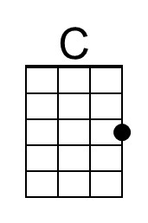 | 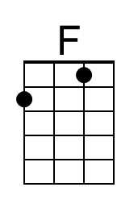 | 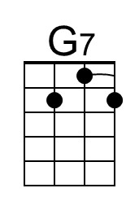 |  | Bari | 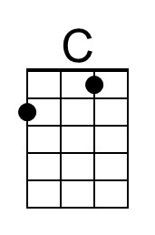 | 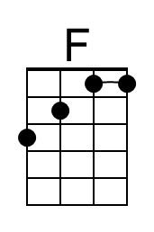 | 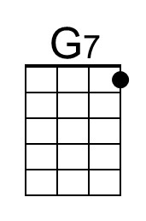

Amazing Grace (John Newton, 1772) (G)

Intro: Last 2 lines of Verse  G C G  A-mazing Grace, how sweet the sound,  D7  That saved a wretch like me.  G C G  I once was lost but now am found,  D7 G  Was blind, but now I see.  G C G  T'was Grace that taught my heart to fear.  D7  And Grace, my fears relieved.  G C G  How precious did that Grace appear  D7 G  The hour I first believed.  G C G  Through many dangers, toils and snares  D7  I have already come;  G C G  'Tis Grace that brought me safe thus far  D7 G  and Grace will lead me home. |  |  |  | G C G  The Lord has promised good to me.  D7  His word my hope secures.  G C G  He will my shield and portion be,  D7 G  As long as life endures.  G C G  Yea, when this flesh and heart shall fail,  D7  And mortal life shall cease,  G C G  I shall possess within the veil,  D7 G  A life of joy and peace.  G C G  When we've been here ten thousand years  D7  Bright shining as the sun.  G C G  We've no less days to sing God's praise  D7 G  Than when we've first begun.  Repeat 1st Verse
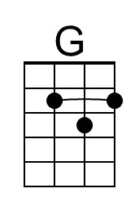 |  | 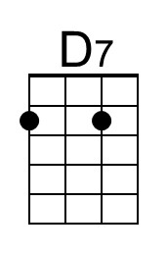 |  | Bari | 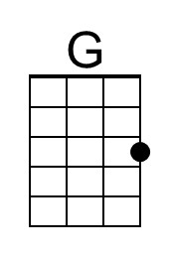 |  | 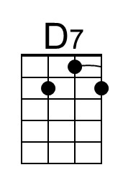

Amazing Grace (John Newton, 1772) (F)

Intro: Last 2 lines of Verse  F B♭ F  A-mazing Grace, how sweet the sound,  C7  That saved a wretch like me.  F B♭ F  I once was lost but now am found,  C7 F  Was blind, but now I see.  F B♭ F  T'was Grace that taught my heart to fear.  C7  And Grace, my fears relieved.  F B♭ F  How precious did that Grace ap-pear  C7 F  The hour I first believed.  F B♭ F  Through many dangers, toils and snares  C7  I have already come;  F B♭ F  'Tis Grace that brought me safe thus far  C7 F  and Grace will lead me home. |  |  |  | F B♭ F  The Lord has promised good to me.  C7  His word my hope secures.  F B♭ F  He will my shield and portion be,  C7 F  As long as life endures.  F B♭ F  Yea, when this flesh and heart shall fail,  C7  And mortal life shall cease,  F B♭ F  I shall possess within the veil,  C7 F  A life of joy and peace.  F B♭ F  When we've been here ten thousand years  C7  Bright shining as the sun.  F B♭ F  We've no less days to sing God's praise  C7 F  Than when we've first begun.  Repeat 1st Verse
 | 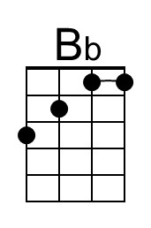 | 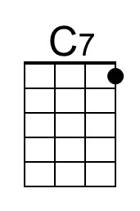 |  | Bari |  | 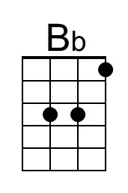 | 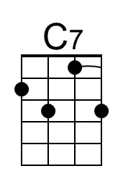

Amazing Grace (John Newton, 1772) (C)

Intro: Last 2 lines of Verse  C F C  A-mazing Grace, how sweet the sound,  G7  That saved a wretch like me.  C F C  I once was lost but now am found,  G7 C  Was blind, but now I see.  C F C  T'was Grace that taught my heart to fear.  G7  And Grace, my fears relieved.  C F C  How precious did that Grace appear  G7 C  The hour I first believed.  C F C  Through many dangers, toils and snares  G7  I have already come;  C F C  'Tis Grace that brought me safe thus far  G7 C  and Grace will lead me home. |  |  |  | C F C  The Lord has promised good to me.  G7  His word my hope secures.  C F C  He will my shield and portion be,  G7 C  As long as life endures.  C F C  Yea, when this flesh and heart shall fail,  G7  And mortal life shall cease,  C F C  I shall possess within the veil,  G7 C  A life of joy and peace.  C F C  When we've been here ten thousand years  G7  Bright shining as the sun.  C F C  We've no less days to sing God's praise  G7 C  Than when we've first begun.  Repeat 1st Verse
 |  |  |  | Bari

This page is intentionally blank.

