American Tune (Paul Simon)





C F C G7 C G C Am E7 Am
G
C
G7
F
Many's the time I've been mis-ta-ken and many times confused
C F C G7 C G C Am E7 Am C7
Yes and I've of - ten felt for-sa-ken and certainly misused
F G F C F C G Am A7
Aw, but I'm all right, I'm all right, I'm just weary to my bones


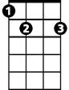

D7 G7 C G7 D G
Dm
C7
E7
Am
Still you don't expect to be bright and bon vivant
F C G E7 Am Dm C G C
So far away from home, so far away from home

C F C G7 C G E7
And I don't know a soul who's not been ba t-tered
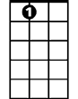
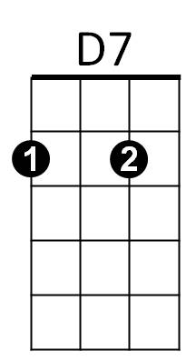

Am E7 Am
A7
D
I don't have a friend that feels at ease
C F C G7 C G C Am E7 Am C7
I don't know a dream that's not been shattered or driven to its knees
F G F C F C G Am A7
Aw, but it's all right, it's all right for we lived so well so long
D7 G7 C G7 D G
Still when I think of the road we're travelin' on
F C G E7 Am
I wonder what's gone wrong,
Dm C G C
BARITONE

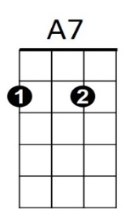
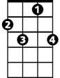

I can't help but wonder what's gone wrong
C
G
F
G7
Am
Em
C7
Dm
D7
D
C
And I dreamed I was dying...
G G7 Am
I dreamed that my soul rose unexpectedly
G7 F C G G7
And looking back down on me smiled reassuringly
C
And I dreamed I was flying....
G G7 Am
And high up above my eyes could clearly see
G7 C G G7
The Statue of Liberty - sailing away to sea
C
And I dreamed I was flying....
C F C G C G E7
For we come on the ship they call the Mayflower
Am E7 Am
We come on the ship that sailed the moon
C F C G C G C
We come in the age’s most un - certain hours
Am E7 Am C7
And sing an American Tune
F G F C F C G Am A7
Aw, but it's all right, it's alright it’s alright you can't be for – ever blessed
D7 G C G7 D G
Still tomorrow's gonna be a - nother working day
C F C G E7 Am Dm C G G7 C G C F G7 C
And I'm trying to get some rest, that's all I'm trying to get some rest

