Amie (Travis Tritt)

Intro: G C

G C
Fallin' in and out of love with you
G C
Fallin' in and out of love with you
G C
Don't know what I'm gonna do, ‘cause I keep -
G C Bb D7
Fallin' in and out of love.

G F C / G F C

G F G
I can see why you think you belong to me
C G
I never tried to make you think or let you see one thing
C
for yourself
Bb C
But now you're off with someone else and I'm alone
Bb D
You see I thought that I might keep you for my own.

Chorus:
G F C G
Amie, what you wanna do
F C
I think I could stay with you
Am D
For a while, maybe longer, if I knew.

G F C / G F C

G F G
Don't you think the time is right for us to find
C G
All the things we thought weren't proper could be right in time
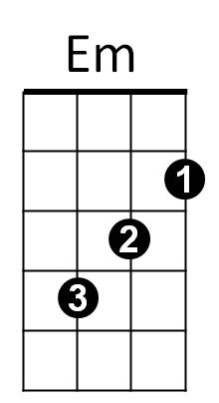
C Bb
And can't you see, which way we should turn together
C
or alone
Bb D
I can't ever see what's right or what is, wrong
(It'll take too long, you see)

(Chorus)
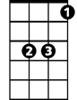
BARITONE
Bb
G
C
D
Em
F
(Instrumental verse)
Am

(Chorus) G F C

G F G
Now it's come to what you want, you've had it your way
C G
And all the things you thought before just faded into gray
C
and can't you see
Bb C
That I don't know if it's you or if it's me
Bb D
If it's one of us I'm sure we both will, see

(Won't you look at me and tell me)

G F C G
Amie, what you wanna do
F C
I think I could stay with you
Am D
For a while, maybe longer - longer if I do, yeah now…

(Chorus)

G C
‘Cause I keep…Fallin' in and out of love with you
G C
Fallin' in and out of love with you
G C
Don't know what I'm gonna do
G C Bb D G
Cause I keep, fallin' in and out of love with you-u-u.
G
Bb
C

F
D
Am

