Anything Goes (Cole Porter)

Intro: G / G6 / G / G7 / C / Cm / G / D7 /
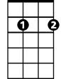


G6
G7
G
G G6
In olden days a glimpse of stocking
G G7
Was looked on as something shocking
C Cm G G6 Am7 D7
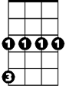

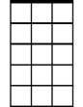
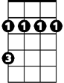
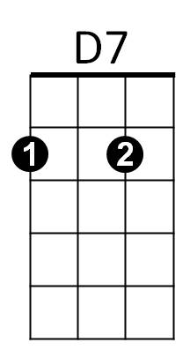
Now heaven knows, anything goes
Cm
C
Am7
Bm

G G6
Good authors too who once knew better words
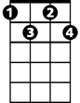
G G7
Fdim
now only use four letter words
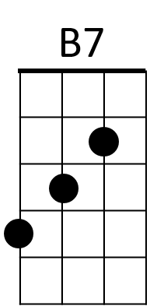
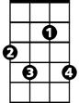
C Cm G F#7
F#7
Writing prose, anything goes

B7 F#7 B7
The world has gone mad today and good's bad today
F#7 B7
And black's white today and day's night today
Bm Bm7 Fdim D7
When most guys today that women prize today are just silly gigo-los
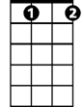
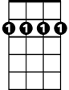
Gdim
Fdim
Bm7
G G6
So though I'm not a great romancer,
G G7
I know that you're bound to answer
C Cm G G7
When I pro-pose, anything goes
C Cm G Gdim G6
BARITONE
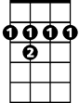
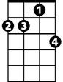
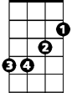
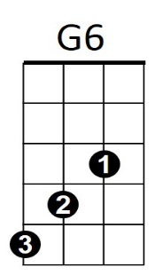
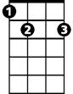
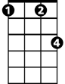


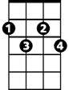
Now it's time to close, 'cause anything goes!
D7
F#7
Am7
Bm
G
B7
Bm7
Fdim
Cm
G7
C
Gdim

Anything Goes Original Lyrics (Cole Porter)
Times have changed
And we've often rewound the clock
Since the Puritans got a shock
When they landed on Plymouth Rock.
If today any shock they should try to stem
'Stead of landing on Plymouth Rock,
Plymouth Rock would land on them.

In olden days a glimpse of stocking
Was looked on as something shocking
Now heaven knows, anything goes

If driving fast cars you like, if low bars you like,
If old hymns you like, if fair limbs you like,
If Mae West you like, or me undressed you like
Well no-body will op-pose

When every night the set that’s smart is intruding
in nudist parties in studios – anything goes

When Mrs. Ned McLean, God Bless her,
Can get Russian Reds to “yes” her, then I suppose-anything goes

When Rockefeller still can hoard e-
‘nuff money to let Max Gordon produce his shows, anything goes

The world has gone mad today and good's bad today
And black's white today and day's night today
And that gent today you gave a cent today once had several chateaux

When folks who still can ride in Jitneys
find out Vanderbilts and Whitneys lack baby clothes – anything goes

When Sam Goldwyn can with great conviction
Instruct Anna Sten in diction, then Nana shows – anything goes

When you hear that Lady Mendl standing up
now turns a handspring landing up on her toes– anything goes

Just think of those shocks you got, and those knocks you got
And those blues you got from those news you got
And those pains you got if any brains you got
From those little radi-os

So Mrs. R with all her trimmin’s
can broadcast a bed from Simmons
‘Cause Franklin knows – anything goes

