Apple Pie (Spirit In The Sky parody)
C101 C
Original music & lyrics by Norman Greenbaum (1969); Adaptation by JoyLily
Apple Pie by JoyLily

Intro (2x)  | C | F D# C C | C | F C D# C |  C  When we dine on turkey that's dressed  F  That’s the night that we all eat the best  C  Even when the cranberry’s dry  G C  Gonna enjoy that apple pie.  C  Gonna enjoy that apple pie.  F  That's what we’ll do on that special high  C  When we dine on turkey that's dressed  G C  That’s the night that we all eat the best.  Instrumental (2x)  | C | F D# C C | C | F C D# C |  C  Prepare yourself you know it's a must  F  Wear your special pants or you’ll bust.  C  With all this food, you’ll be fine.  G C  Un-buckle your pants for that apple pie.  C  Un-buckle your pants for that apple pie.  F  That's what we’ll do on that special high  C  On the night that the turkey is dressed  G C  That’s the night that we all eat the best. | Instrumental (2x)  | C | F D# C C | C | F C D# C |  C  We’ll start a diet some time next year  F  For now, please, pants don’t bust  C  With all this food, we’ll be fine.  G C  Un-buckle your belt for that apple pie.  C  Load me up with that apple pie.  F  That's what I want on that special night.  C  Don’t give a darn* a-bout all the rest.  G C  I want the part of the meal that’s the best!  G C  Give me the dessert that’s the best!  Outro (2x)  | C | F D# C C | C | F C D# C |
 | 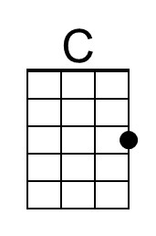 | 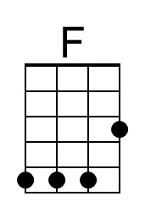 | 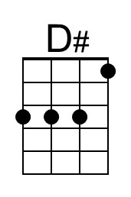 | 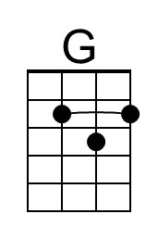
 | Baritone
 | 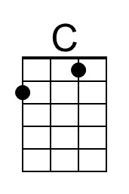 | 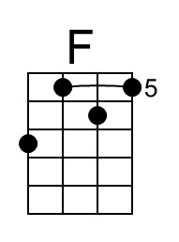 | 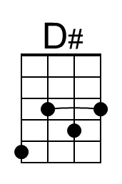 | 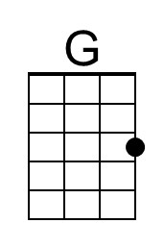

* “Darn” was not the original lyric, but I didn’t feel that “cr*p” was appropriate for a family-safe web site.

Apple Pie (Spirit In The Sky parody)
C101 G
Original lyrics by Norman Greenbaum (1969); Adaptation by JoyLily
Apple Pie by JoyLily

Intro (2x)  | G | G C Bb G | G | G Bb C G |  G  When we dine on turkey that's dressed  C  That’s the night that we all eat the best  G  Even when the cranberry’s dry  D G  Gonna enjoy that apple pie.  G  Gonna enjoy that apple pie.  C  That's what we’ll do on that special high  G  When we dine on turkey that's dressed  D G  That’s the night that we all eat the best.  Instrumental (2x)  | G | G C Bb G | G | G Bb C G |  G  Prepare yourself you know it's a must  C  Wear your special pants or you’ll bust.  G  With all this food, you’ll be fine.  D G  Un-buckle your pants for that apple pie.  G  Un-buckle your pants for that apple pie.  C  That's what we’ll do on that special high  G  On the night that the turkey is dressed  D G  That’s the night that we all eat the best. | Instrumental (2x)  | G | G C Bb G | G | G Bb C G |  G  We’ll start a diet some time next year  C  For now, please, pants don’t bust  G  With all this food, we’ll be fine.  D G  Un-buckle your belt for that apple pie.  G  Load me up with that apple pie.  C  That's what I want on that special night.  G  Don’t give a darn* a-bout all the rest.  D G  I want the part of the meal that’s the best!  D G  Give me the dessert that’s the best!  Outro (2x)  | G | G C Bb G | G | G Bb C G |
 |  | 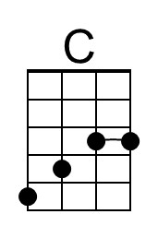 | 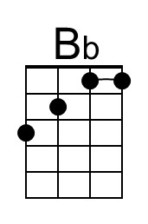 | 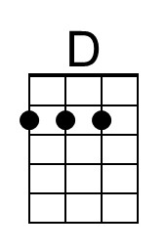
 | Baritone
 |  | 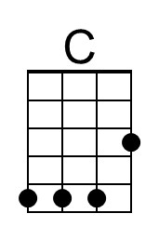 | 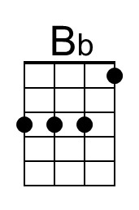 | 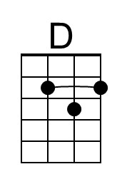

* “Darn” was not the original lyric, but I didn’t feel that “cr*p” was appropriate for a family-safe web site.

