Apples And Bananas (Traditional North American Children's Song)
Apples and Bananas (Alt.) by Raffi from “One Light, One Sun” (1985)

Intro C G7  C G7  I like to eat, eat, eat apples and bana-nas  C  I like to eat, eat, eat apples and bana-nas  G7 C G7  I like to ate, ate, ate epples and bene-nes  C  I like to ate, ate, ate epples and bene-nes  G7 C G7  I like to eat, eat, eat eepples and beenee-nees  C D  I like to eat, eat, eat eepples and beenee-nees  A7 D A7  And I like to ite, ite, ite ipples and bini-nis  D  I like to ite, ite, ite ipples and bini-nis  A7 D A7  I like to ote, ote, ote, oplles and bono-nos  D  I like to ote, ote, ote, oplles and bono-nos  A7 D A7  And I like to ute, ute, ute upples and bunu-nus  D A7 D  I like to ute, ute, ute upples and bunu-nus. |  |  |  |  |  |  | 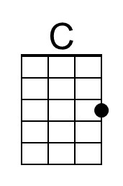
 |  |  |  |  |  |  | 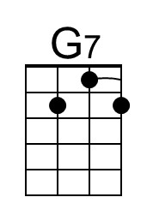
 |  |  |  |  |  |  | 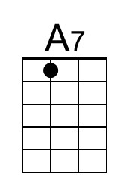
 |  |  |  |  |  |  | 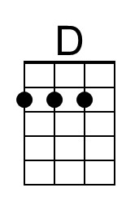
 |  |  | Bari | 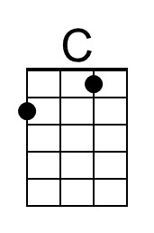 | 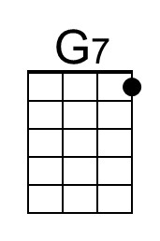 | 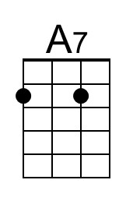 | 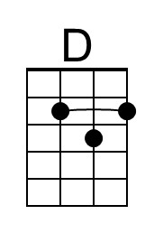

Apples And Bananas (Traditional North American Children's Song)
Apples and Bananas (Alt.) by Raffi from “One Light, One Sun” (1985)

Intro G D7  G D7  I like to eat, eat, eat apples and bana-nas  G  I like to eat, eat, eat apples and bana-nas  D7 G D7  I like to ate, ate, ate epples and bene-nes  G  I like to ate, ate, ate epples and bene-nes  D7 G D7  I like to eat, eat, eat eepples and beenee-nees  G A  I like to eat, eat, eat eepples and beenee-nees  E7 A E7  And I like to ite, ite, ite ipples and bini-nis  A  I like to ite, ite, ite ipples and bini-nis  E7 A E7  I like to ote, ote, ote, oplles and bono-nos  A  I like to ote, ote, ote, oplles and bono-nos  E7 A E7  And I like to ute, ute, ute upples and bunu-nus  A E7 A  I like to ute, ute, ute upples and bunu-nus. |  |  |  |  |  |  | 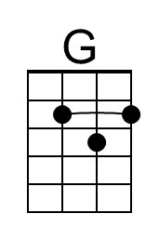
 |  |  |  |  |  |  | 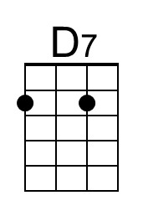
 |  |  |  |  |  |  | 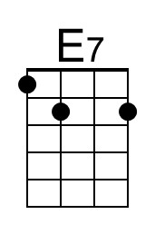
 |  |  |  |  |  |  | 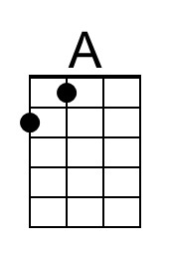
 |  |  | Bari | 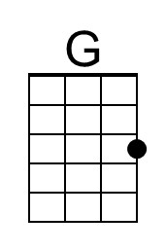 | 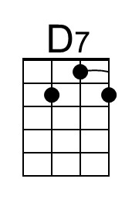 | 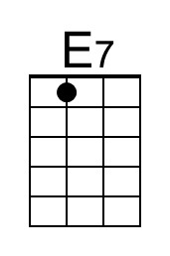 | 