April Come She Will (Paul Simon) Key C

Intro: C F C F C

C F C F C F C
A - pril, come she will
Dm Am Bbmaj7 Am
When streams are ripe and swelled with rain





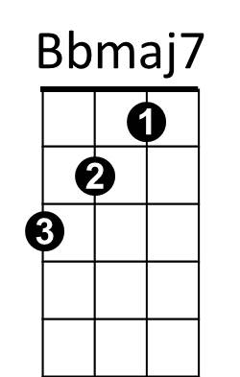
F G C Am
Dm
F
C
G
Am
Ma -y, she will sta - y
Dm Am Dm Am C F C F
Resting in my arms again

C F C F C F C
Ju - ne, she'll change her tune
Dm Am Bbmaj7 Am
In restless walks she'll prowl the night
F G C Am
Ju - ly, she will f - ly
Dm Am Dm Am C F C F
And give no warning to her flight

C F C F C F C
Au - gust, die she must
Dm Am Bbmaj7 Am
The autumn winds blow chilly and cold
F G C Am
Septe - mber, I'll remem-ber
Dm Am G C C F C F C F C
A love once new has now grown old

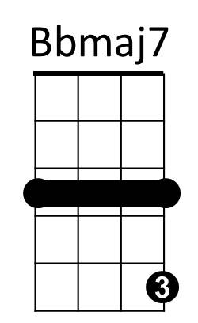


BARITONE
C
Dm
F
G
Am

April Come She Will (Paul Simon) Key G

Intro: G C G C G

G C G C G C G
Am
C
G
A - pril, come she will
Am Em Fmaj7 Em
When streams are ripe and swelled with rain
C D G Em
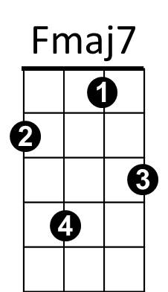
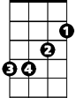
Ma -y, she will sta - y
Em

Am Em Am Em G C G C
D
Resting in my arms again

G C G C G C G
Ju - ne, she'll change her tune
Am Em Fmaj7 Em
In restless walks she'll prowl the night
C D G Em
Ju - ly, she will f - ly
Am Em Am Em G C G C
And give no warning to her flight

G C G C G C G
Au - gust, die she must
Am Em Fmaj7 Em
The autumn winds blow chilly and cold
C D G Em
Septe - mber, I'll remem-ber
Am Em D G G C G C G C G
A love once new has now grown old

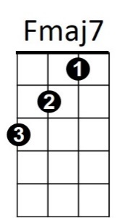
D
Em
Am
G
C
BARITONE

