April Love (Paul Francis Webster / Sammy Fain)

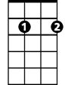
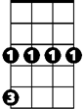
G Em7 Am7 D7 G Em7 Am7 D7
G
Em7
Cm
Ap...ril lo ve, is for the very young.
G Em A7 D7 G D7
Every star's a wishing star, that shines - for you.
G Em7 Am7 D7 G Bm

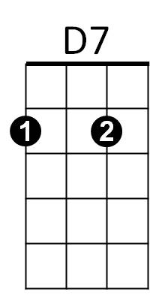
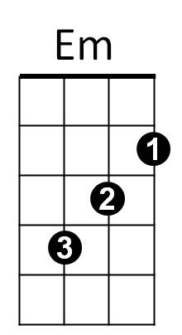
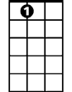
Ap...ril love is all the seven wonders,
Am7
A7
Em G D A7 Am7 D7
One little kiss can tell you, this is true.

Bm7 Am7 D7 Am7 D7 Am7 D7 G
Some...times, an April day, will sudden..ly bring showers.
Em7 A7 D A7 D7
Rain to grow the flowers, for her first bou-quet.
G Em7 Am7 D7 G Cm
But Ap...ril love, can slip right through your fingers.

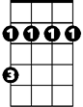
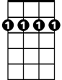
G E7 Am7 D7 G D D7
D
Bm
Bm7
So, if she's the one, don't let her run away.

Bm7 Am7 D7 Am7 D7 Am7 D7 G
Some...times, an April day, will sudden..ly bring showers.
Em7 A7 D A7 D7
Rain to grow the flowers, for her first bouquet.
G Em7 Am7 D7 G Cm
But Ap...ril love, can slip right through your fingers.
G E7 Am7 D7 G D D7
So, if she's the one, don't let her run a-way.
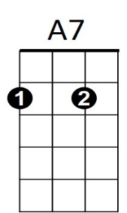
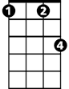
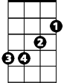

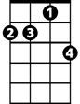


Cm
Bm
D
Bm7
G
Em7
Am7
D7
Em
BARITONE

