As Tears Go By - Rolling Stones



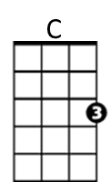
Intro: C D F G7
F
D

C D F G7
It is the evening of the da-ay
C D F G7
I sit and watch the children pla-ay


F G7
G7
Am
Smiling faces I can see
C Am
But not for me
F G7
I sit and watch as tears go by

C D F G7
My richness can't buy everythi-ing
C D F G7
I want to hear the children si-ing
F G7
All I hear is the sound
C Am
BARITONE

of rain falling on the ground
C
D
F G7
I sit and watch as tears go by

C D F G7
It is the evening of the da-ay


C D F G7
G7
F
I sit and watch the children pla-ay
F G7
Doing things I used to do
C Am
Thinking of you

F G7
Am
I sit and watch as tears go by

OUTRO (2x)
C D F G7
Hmm Hmm Hmm Hmm Hmm Hmm Hmm Hmm

