Auld Lang Syne
C02



C C7 F G7
G7
C
Should auld acquaintance be for-got
C C7 F
And never brought to mind?


C C7 F G7
C7
F
Should auld acquaintance be for-got
F G7 C
And days of auld lang syne?

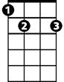
G7 C G7
E7
For auld lang syne, my dear,
C C7 F
For auld lang syne
C C7 G7 E7
We’ll take a cup of kindness yet,
F G7 C
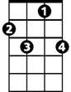
For auld lang syne
C7
G7
C
BARITONE


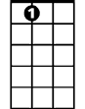
F
E7

