Autumn Leaves (Am)
"Les feuilles mortes" (French lyrics) by Jacques Prévert, Music by Joseph Kosma, 1945
English Lyrics by Johnny Mercer, 1947; Autumn Leaves by Johnny Mercer (1947) (Cm)
Version 1 – 2/2 Time – 81 BPM

Intro: Chords for Verse.  Am Dm7 G7 Cmaj7  The falling leaves __ drift by my window  Fmaj7 Bm7♭5 E7 Am  _____ The autumn leaves __ of red and gold  Am Dm7 G7 Cmaj7  I see your lips, __ the summer kisses  Fmaj7 Bm7♭5 E7 Am – E7 – Am  _____ The sunburned hands, __ I used to hold  Chorus  E7 Am  Since you went away, the days grow long  Dm7 G7 Cmaj7 – Fmaj7  And soon I'll hear __ old winter's song  Bm7♭5 E7 Am7  But I miss you most of all, my darling  Fmaj7 E7 Am  When autumn leaves start to fall.  Instrumental Verse. Repeat Chorus. Outro Dm | Am |  |  |  |  |  | 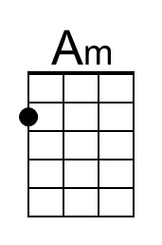 | 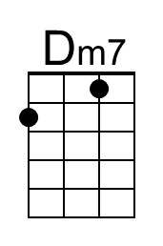
 |  |  |  |  |  | 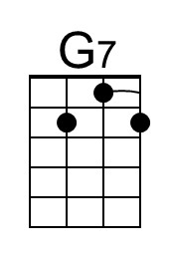 | 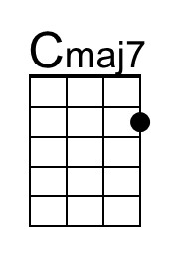
 |  |  |  |  |  | 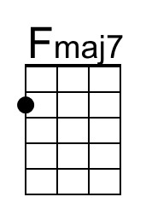 | 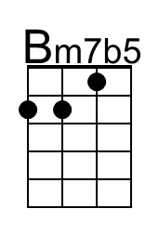
 |  |  |  |  |  | 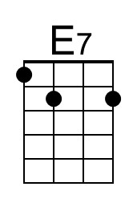 | 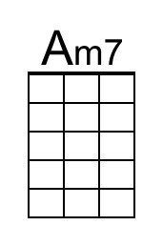
G-Tuned Uke  (Bari) | 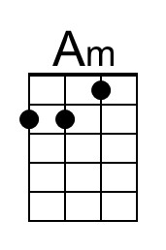 | 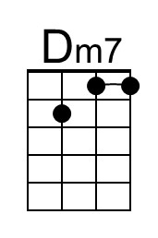 | 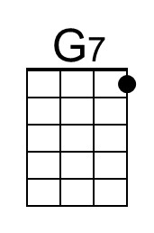 | 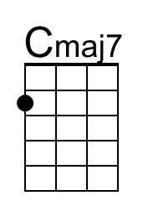 | 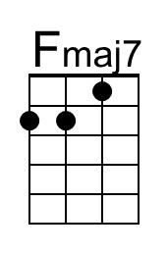 | 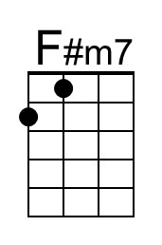 | 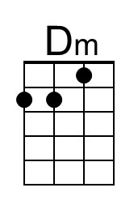
 | 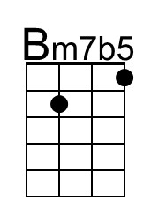 | 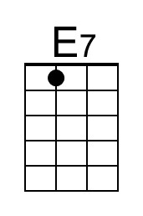 | 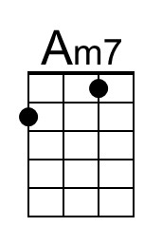 | 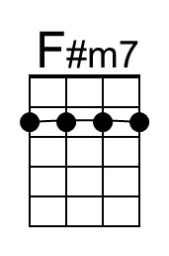 | 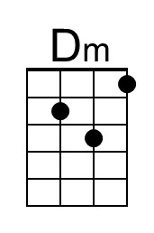

Autumn Leaves (Cm)
"Les feuilles mortes" (French lyrics) by Jacques Prévert, Music by Joseph Kosma, 1945
English Lyrics by Johnny Mercer, 1947; Autumn Leaves by Johnny Mercer (1947) (Cm)
Version 1 – 2/2 Time – 81 BPM

Intro: Chords for Verse.  Cm Fm7 Bb7 Ebmaj7  The falling leaves __ drift by my window  Abmaj7 Dm7b5 G7 Cm  _____ The autumn leaves __ of red and gold  Cm Fm7 Bb7 Ebmaj7  I see your lips, __ the summer kisses  Abmaj7 Dm7b5 G7 Cm – G7 – Cm  _____ The sunburned hands, __ I used to hold  Chorus  E7 Am  Since you went away, the days grow long  Dm7 G7 Cmaj7 – Fmaj7  And soon I'll hear __ old winter's song  Bm7♭5 E7 Am7  But I miss you most of all, my darling  Fmaj7 E7 Am  When autumn leaves start to fall.  Instrumental Verse. Repeat Chorus. Outro Fm | Cm |  |  |  |  |  | 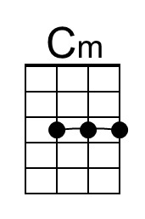 | 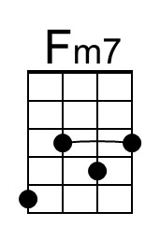
 |  |  |  |  |  | 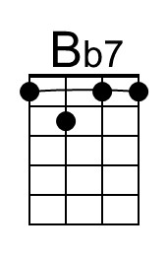 | 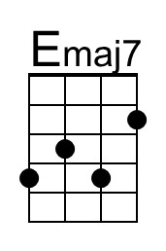
 |  |  |  |  |  | 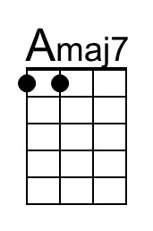 | 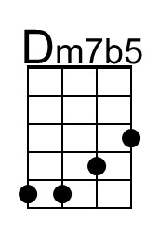
 |  |  |  |  |  |  | 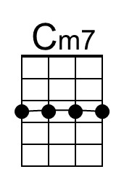
G-Tuned Uke  (Bari) | 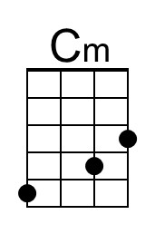 | 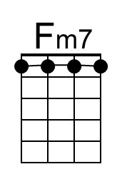 | 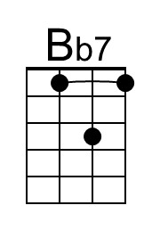 | 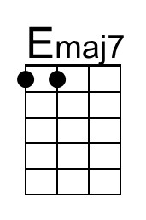 | 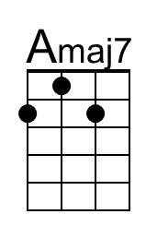 |  | 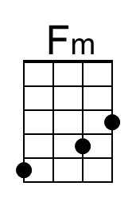
 | 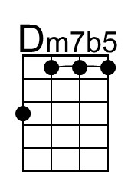 |  | 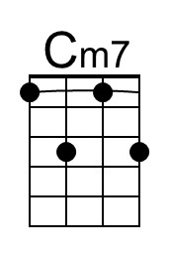 |  | 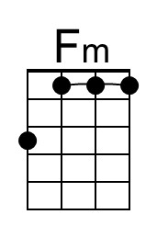

Autumn Leaves (Dm)
"Les feuilles mortes" (French lyrics) by Jacques Prévert, Music by Joseph Kosma, 1945
English Lyrics by Johnny Mercer, 1947; Autumn Leaves by Johnny Mercer (1947) (Cm)
Version 1 – 2/2 Time – 81 BPM

Intro: Chords for Verse.  Dm Gm7 C7 Fmaj7  The falling leaves __ drift by my window  B♭maj7 Em7♭5 A7 Dm  _____ The autumn leaves __ of red and gold  Dm Gm7 C7 Fmaj7  I see your lips, __ the summer kisses  B♭maj7 Em7b♭5 A7 Dm – A7 – Dm  _____ The sunburned hands, __ I used to hold  Chorus  A7 Dm  Since you went away, the days grow long  Gm7 C7 Fmaj7 – Bbmaj7  And soon I'll hear __ old winter's song  Em7♭5 A7 Dm7  But I miss you most of all, my darling  B♭maj7 A7 Dm  When autumn leaves start to fall.  Instrumental Verse. Repeat Chorus. Outro Gm | Dm |  |  |  |  |  |  | 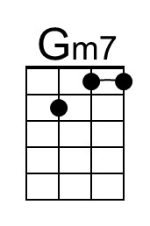
 |  |  |  |  |  | 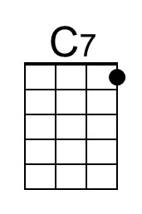
 |  |  |  |  |  | 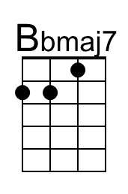 | 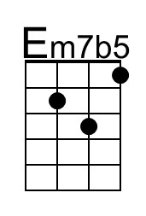
 |  |  |  |  |  | 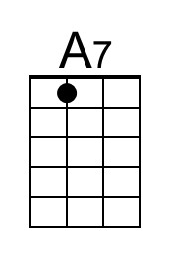
G-Tuned Uke  (Bari) |  | 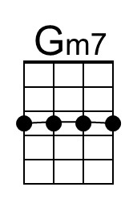 | 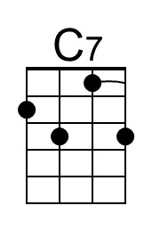 |  | 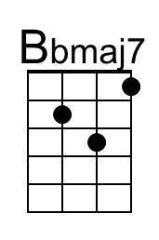 | 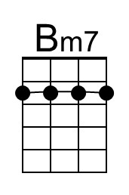 | 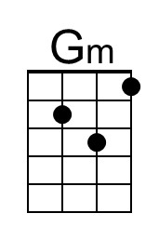
 | 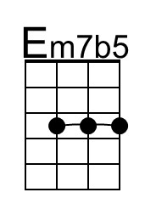 | 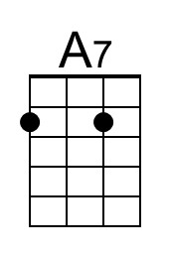 |  | 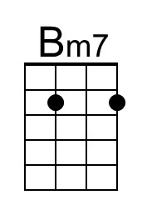 | 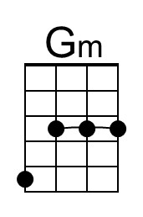

Autumn Leaves (Em)
"Les feuilles mortes" (French lyrics) by Jacques Prévert, Music by Joseph Kosma, 1945
English Lyrics by Johnny Mercer, 1947; Autumn Leaves by Johnny Mercer (1947) (Cm)
Version 1 – 2/2 Time – 81 BPM

Intro Chords for Verse  Em Am7 D7 Gmaj7  The falling leaves __ drift by my window  Cmaj7 F♯m7♭5 B7 Em  _____ The autumn leaves __ of red and gold  Em Am7 D7 Gmaj7  I see your lips, __ the summer kisses  Cmaj7 F♯m7♭5 B7 Em – B7 – Em  _____ The sunburned hands, __ I used to hold  Chorus  B7 Em  Since you went away, the days grow long  Am7 D7 Gmaj7 – Cmaj7  And soon I'll hear __ old winter's song  F♯m7♭5 B7 Em7  But I miss you most of all, my darling  Cmaj7 B7 Em  When autumn leaves start to fall.  Instrumental Verse. Repeat Chorus. Outro | Am | Em | |  |  |  |  |  | 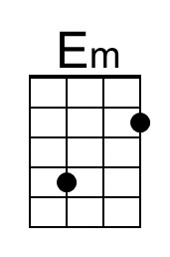
 |  |  |  |  |  | 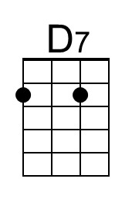 | 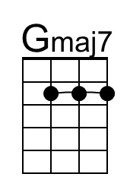
 |  |  |  |  |  |  | 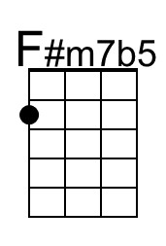
 |  |  |  |  |  | 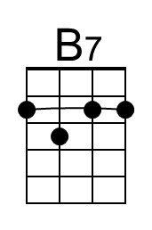 | 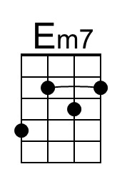
 |  |  |  |  |  | 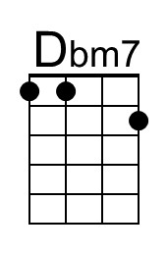
G-Tuned Uke  (Bari) | 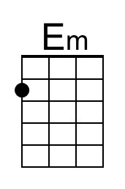 |  | 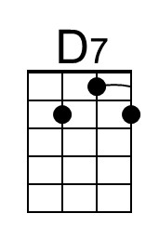 | 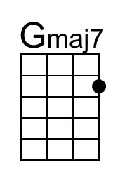
 | 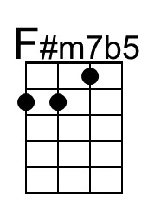 | 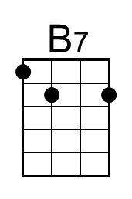 | 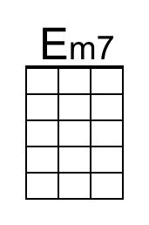 | 