Autumn Leaves
French lyrics by Jacques Prévert, Music by Joseph Kosma, 1945
English Lyrics by Johnny Mercer, 1947

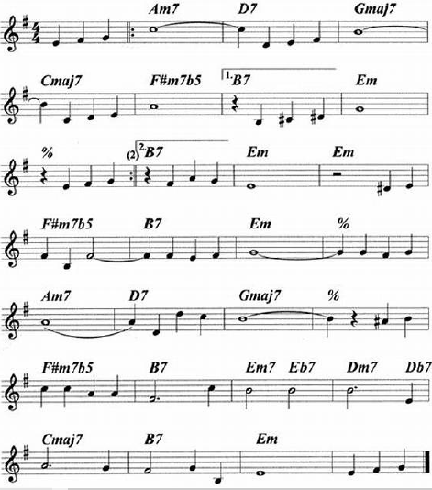

Autumn Leaves
French lyrics by Jacques Prévert, Music by Joseph Kosma, 1945
English Lyrics by Johnny Mercer, 1947
Autumn Leaves by Johnny Mercer (1947); Autumn Leaves by Frank Sinatra (1957)
Chords for C-Tuned and G-Tuned Ukulele
Em Am7 D7 Gmaj7  The falling leaves __ drift by my window  Cmaj7 F#m7♭5 B7 Em  _____ The falling leaves __ of red and gold  Em Am7 D7 Gmaj7  I see your lips, __ the summer kisses  Cmaj7 F#m7♭5 B7 Em  _____ The sunburned hands, __ I used to hold  Chorus  F#m7♭5 B7 Em  Since you went away __ the days grow long  Am7 D7 Gmaj7  And soon I'll hear __ old winter's song  F#m7♭5 B7 Em7 E♭7 Dm7  But I miss you most of all, my darl - ing  D♭7 Cmaj7 B7 Em  When autumn leaves start to fall. |  |  |  |  |  | 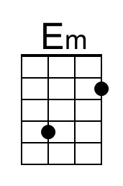 | 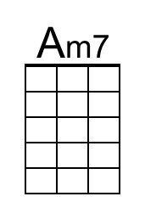
 |  |  |  |  |  | 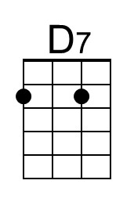 | 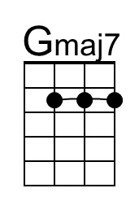
 |  |  |  |  |  | 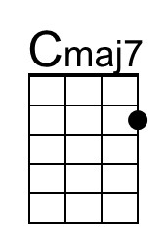 | 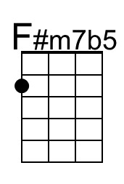
 |  |  |  |  |  | 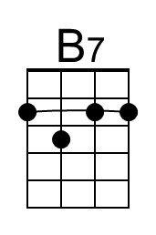 | 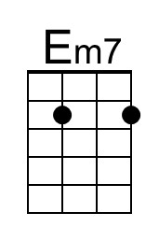
G-Tuned Uke  (Bari) | 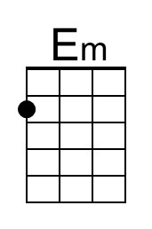 | 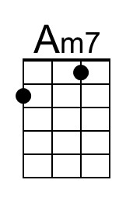 | 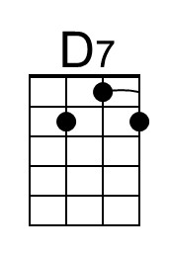 | 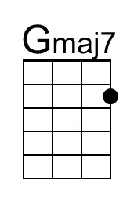 | 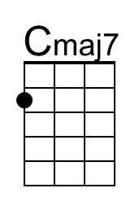 | 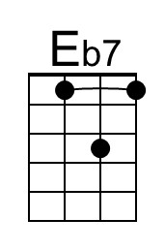 | 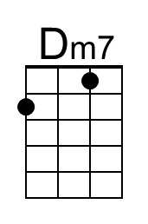
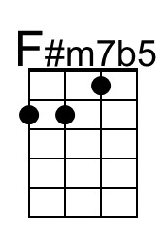 | 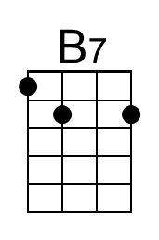 | 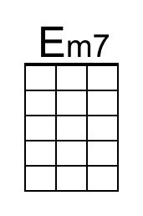 | 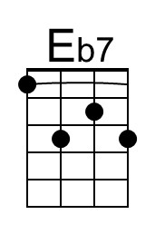 | 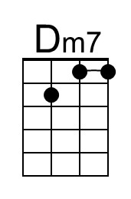 | 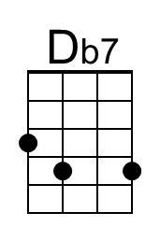 |  | 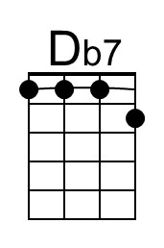

Autumn Leaves
French lyrics by Jacques Prévert, Music by Joseph Kosma, 1945
English Lyrics by Johnny Mercer, 1947
Autumn Leaves by Johnny Mercer (1947); Autumn Leaves by Frank Sinatra (1957)

Em Am7 D7 Gmaj7
The falling leaves __ drift by my window
Cmaj7 F#m7b5 B7 Em
_____ The falling leaves __ of red and gold

Em Am7 D7 Gmaj7
I see your lips, __ the summer kisses
Cmaj7 F#m7b5 B7 Em
_____ The sunburned hands, __ I used to hold

Chorus
F#m7b5 B7 Em
Since you went away __ the days grow long
Am7 D7 Gmaj7
And soon I'll hear __ old winter's song
F#m7♭5 B7 Em7 E♭7 Dm7
But I miss you most of all, my darl - ing
D♭7 Cmaj7 B7 Em
When autumn leaves start to fall.

