Autumn Leaves
French lyrics by Jacques Prévert, Music by Joseph Kosma, 1945
English Lyrics by Johnny Mercer, 1947
Autumn Leaves by Johnny Mercer (1947)
Chords for C-Tuned and G-Tuned Ukulele – Version 4 – Key of Em – 2/2 Time –  = 60
Intro: Chords for Verse  Em Am7 D7 Gmaj7  The falling leaves __ drift by my window  Cmaj7 F#m7♭5 B7 Em  _____ The falling leaves __ of red and gold  Em Am7 D7 Gmaj7  I see your lips, __ the summer kisses  Cmaj7 F#m7♭5 B7 Em  _____ The sunburned hands, __ I used to hold  Chorus  B7 Em  Since you went away, the days grow long  Am7 D7 Gmaj7  And soon I'll hear __ old winter's song  F#m7♭5 B7 Em7 - D♭m7  But I miss you most of all, my darling  Cmaj7 B7 Em  When autumn leaves start to fall.  Instrumental Verse. Repeat Chorus. Outro: | Am | Em | |  |  |  |  |  | 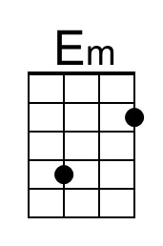 | 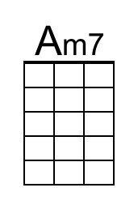
 |  |  |  |  |  | 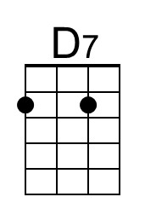 | 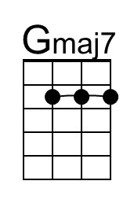
 |  |  |  |  |  | 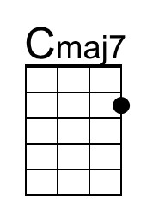 | 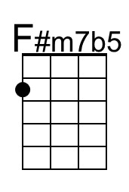
 |  |  |  |  |  | 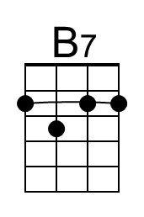 | 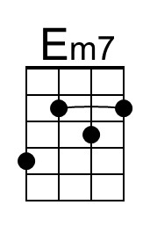
 |  |  |  |  |  |  | 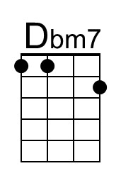
G-Tuned Uke  (Bari) | 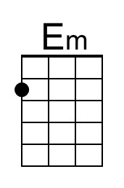 | 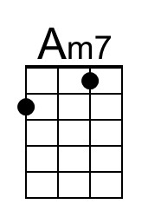 | 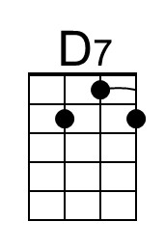 | 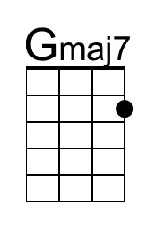
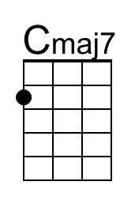 | 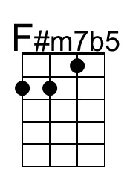 | 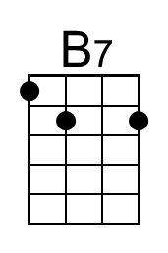 | 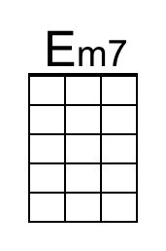 | 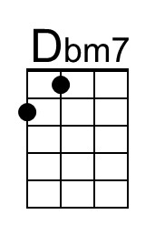

Autumn Leaves
French lyrics by Jacques Prévert, Music by Joseph Kosma, 1945
English Lyrics by Johnny Mercer, 1947; Autumn Leaves by Johnny Mercer (1947)
Version 4 – Key of Em – 2/2 Time –  = 60

Intro: Chords for Verse.

Em Am7 D7 Gmaj7
The falling leaves __ drift by my window
Cmaj7 F#m7b5 B7 Em
_____ The falling leaves __ of red and gold

Em Am7 D7 Gmaj7
I see your lips, __ the summer kisses
Cmaj7 F#m7b5 B7 Em
_____ The sunburned hands, __ I used to hold

Chorus
B7 Em
Since you went away, the days grow long
Am7 D7 Gmaj7
And soon I'll hear __ old winter's song
F#m7♭5 B7 Em7 - D♭m7
But I miss you most of all, my darling
Cmaj7 B7 Em
When autumn leaves start to fall.

Instrumental Verse.

Repeat Chorus.

Outro: | Am | Em |

Bb7b9

GCEA | DGBE
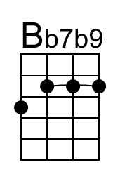 | 