Autumn Leaves Key Am
(Johnny Mercer / Jacques Andre Marie Prevert / Joseph Kosma)

Intro: Dm G C Am Dm Em (Am x2)

Am



Am Dm G C
Dm
G
C
The falling leaves drift by my window
Dm E7 Am
The falling leaves of red and gold
Dm G C
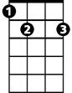
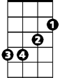

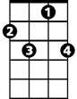
I see your lips, the summer kisses
E7
Em
F
F7
Dm E7 Am
The sunburned hands I used to hold

E7 Am
Since you went away the days grow long
Dm G C
And soon I'll hear old winter's song
F Dm E7 Am
But I miss you most of all, my darling
F7 E7 Am
When autumn leaves start to fall

(Instrumental first verse)

E7 Am
BARITONE

Since you went away the days grow long
Am
C
G
Dm
Dm G C
And soon I'll hear old winter's song
F Dm E7 Am
But I miss you most of all, my darling
F7 E7 Am

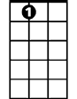
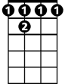
When autumn leaves start to fall
F
E7
Em
F 7
F Dm E7 Am
But I miss you most of all, my darling
F7 E7 Am
When autumn leaves start to fall

Autumn Leaves Key Dm
(Johnny Mercer / Jacques Andre Marie Prevert / Joseph Kosma)

Intro: Gm C F Dm Gm Am (Dm x2)
Dm
F
C
Gm
Bb
Dm Gm C F
The falling leaves drift by my window
Gm A7 Dm
The falling leaves of red and gold
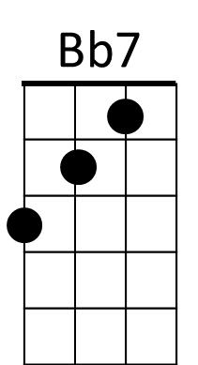
Gm C F
A7
Am
I see your lips, the summer kisses
Gm A7 Dm
The sunburned hands I used to hold

A7 Dm
Since you went away the days grow long
Gm C F
And soon I'll hear old winter's song
Bb Gm A7 Dm
But I miss you most of all, my darling
Bb7 A7 Dm
When autumn leaves start to fall

(Instrumental first verse)

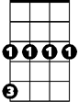
A7 Dm
Gm
BARITONE
C
F
Dm
Since you went away the days grow long
Gm C F
And soon I'll hear old winter's song
Bb Gm A7 Dm
But I miss you most of all, my darling
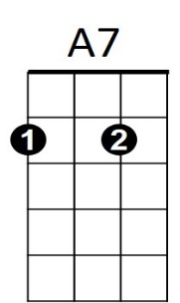
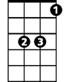
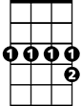
Bb7 A7 Dm
Am
Bb
Bb7
When autumn leaves start to fall
Bb Gm A7 Dm
But I miss you most of all, my darling
Bb7 A7 Dm
When autumn leaves start to fall

