Baby Driver (Paul Simon)

C
My daddy was the family bassman
My mamma was an engineer
And I was born - One dark grey morn
F
With music coming in my ears
C
In my ears

Chorus:
F
They call me Baby Driver
And once upon a pair of wheels
C
Hit-the-road-and-I'm gone ah............
C B Bb A
What's my num-ber?
D
I wonder how your engine feels (Ba-ba ba ba ba)
C B Bb A
Scoot down the road - What's my num-ber
D G C
I wonder how your engine feels

C7
Bada da da dadada - Bada da dadada
Bada da dadada - Bada da dadada

F C
Bb
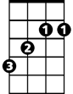
Da da - Bada da da dada
B

C
My daddy was a prominent frogman

My mamma's in the Naval reserve
D
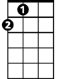
When I was young - I carried a gun
A
A
F
But I never got the chance to serve
C
I did not serve

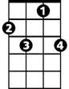


(Chorus)
C7
G
C7

G
C7
Bada da da dadada - Bada da dadada
Bada da dadada - Bada da dadada
F C
Da da - Bada da da dada

C
My daddy got a big promotion
My mamma got a raise in pay
There's no-one home, we're all alone
F
Oh, come into my room and play
C
Yes we can play

F
I'm not talking about your pigtails
But I'm talking 'bout your sex appeal
C
Hit-the-road-and-I'm gone ah............
C B Bb A
What's my num-ber?
D
I wonder how your engine feels (Ba-ba ba ba ba)
C B Bb A
Scoot down the road What's my num-ber
D G C C7 to fade

I wonder how your engine feels
F
C
C
F
BARITONE
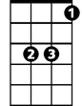
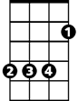
D
Bb
B

