Baby I'm Yours (Van McCoy)
Intro: C A7 Dm G

tacet C A7
Baby I'm yours (baby I’m yours)
Dm
And I'll be yours
G C A7
Until the stars fall from the sky-y-y
Dm G F
Yours until the rivers all run dry
Em Dm G
In other words, until I die

C A7
Baby I'm yours (baby I’m yours)
Dm
And I'll be yours
G C A7
Until the sun no longer shi-i-ines
Dm G F
Yours until the poets run out of rhyme
Em Dm G
In other words, until the end of time

F Dm F Dm
I'm gonna stay right here by your side
Em C
BARITONE
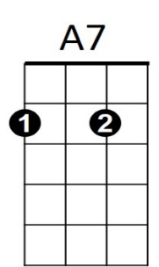


Do my best to keep you satisfied
C
Dm
F Dm
Nothing in the world can drive me away
G Em G
Cause every day you'll hear me say


C A7
F


Baby I'm yours (baby I’m yours)
Em
G
Dm G C A7
And I'll be yours until two and two is three-ee
Dm G F
Yours until the mountain crumbles to the sea
Em Dm G C A7
In other words, until eternity - baby I'm yours

Repeat to fade:

Dm F G C A7
Till the stars fall from the sky - baby I'm yours
Dm F G C A7
Till the rivers all run dry - Baby I'm yours
Dm F
Till the poets run out of rhyme -
G C A7


Baby I'm yours
Dm
A7
C

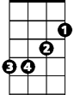

F
Em
G

