Back Home Again (John Denver, 1974) Key A
Intro (Two Measures): A A

A A7
There’s a storm across the valley,
D
clouds are rollin’ in
E7 A
the afternoon is heavy on your shoulders.
A7
There’s a truck out on the four lane,
D
a mile or more away
E7 A
the whinin’ of his wheels just makes it colder.

A A7
He’s an hour away from ridin’
D
on your prayers up in the sky
E7 A
and ten days on the road are barely gone.
A7
There’s a fire softly burning;
D
supper’s on the stove
E7 A A7
but it’s the light in your eyes that makes him warm

Chorus
D E7 A A7
Hey, it’s good to be back home a-gain.
D E7
Sometimes this old farm
A D
feels like a long lost friend.
E7 A
Yes, ‘n, hey it’s good to be back home a-gain.

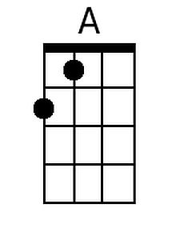
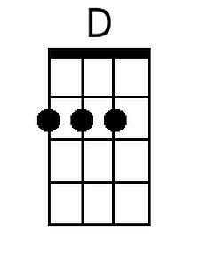
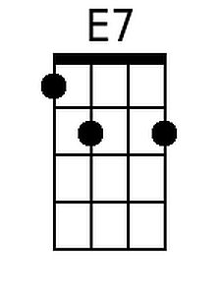
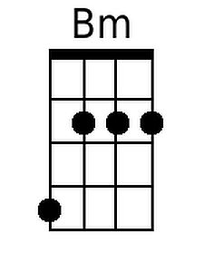
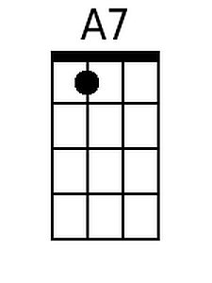

B

A A7
After all the news to tell him:
D
how you spent your time;
E7 A
and what’s the latest thing the neighbors say;
A A7
and your mother called last Friday;
D
“Sunshine” made her cry;
E7 A A7
and you felt the baby move just yester-day.
(Chorus)
D E7 A
And oh, the time that I can lay this tired
D
old body down
Bm E7 A A7
and feel your fingers feather soft u-pon me;
D E7
the kisses that I live for;
A D
the love that lights my way;
Bm D E7
the happiness that livin’ with you brings me.

A A7
It’s the sweetest thing I know of,
D
just spending time with you
E7 A
It’s the little things that make a house a home.
A A7 D
Like a fire softly burning and supper on the stove.
E7 A A7
And the light in your eyes that makes me warm.
(Chorus) 2x
E7 D A
I said, hey it’s good to be back home a-gain.
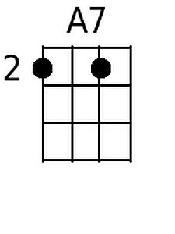
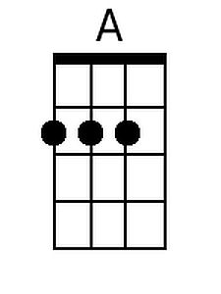
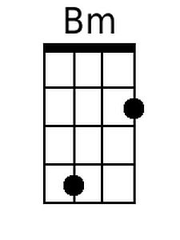
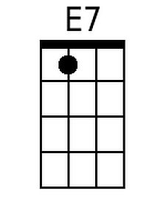
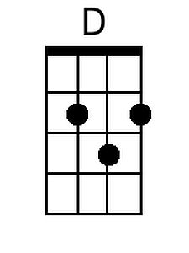
BARITONE

Back Home Again (John Denver, 1974) Key C
Intro (Two Measures): C C

C C7
There’s a storm across the valley,
F
clouds are rollin’ in
G7 C
the afternoon is heavy on your shoulders.
C7
There’s a truck out on the four lane,
F
a mile or more away
G7 C
the whinin’ of his wheels just makes it colder.

C C7
He’s an hour away from ridin’
F
on your prayers up in the sky
G7 C
and ten days on the road are barely gone.
C7
There’s a fire softly burning;
F
supper’s on the stove
G7 C C7
but it’s the light in your eyes that makes him warm

Chorus
F G7 C C7
Hey, it’s good to be back home a-gain.
F G7
Sometimes this old farm
C F
feels like a long lost friend.
G7 C
Yes, ‘n, hey it’s good to be back home a-gain.

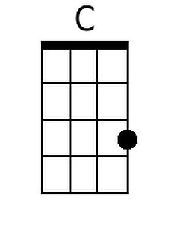
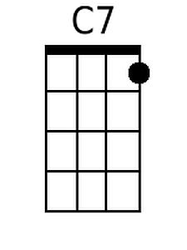
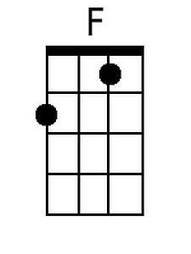
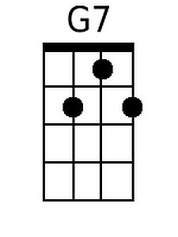
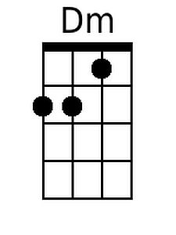

BARITONE

C C7
After all the news to tell him:
F
how you spent your time;
G7 C
and what’s the latest thing the neighbors say;
C C7
and your mother called last Friday;
F
“Sunshine” made her cry;
G7 C C7
and you felt the baby move just yester-day.
(Chorus)
F G7 C
And oh, the time that I can lay this tired
F
old body down
Dm G7 C C7
and feel your fingers feather soft u-pon me;
F G7
the kisses that I live for;
C F
the love that lights my way;
Dm F G7
the happiness that livin’ with you brings me.

C C7
It’s the sweetest thing I know of,
F
just spending time with you
G7 C
It’s the little things that make a house a home.
C C7 F
Like a fire softly burning and supper on the stove.
G7 C C7
And the light in your eyes that makes me warm.
(Chorus) 2x
G7 F C
I said, hey it’s good to be back home a-gain.

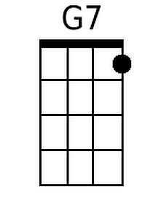
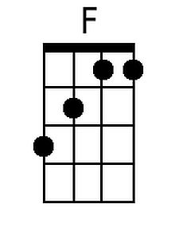
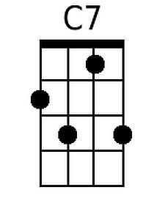
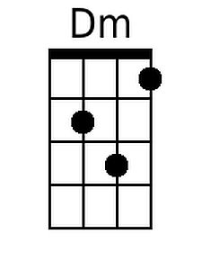
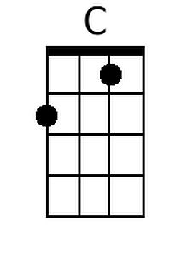

Back Home Again (John Denver, 1974) Key G
Intro (Two Measures): G G

G G7
There’s a storm across the valley,
C
clouds are rollin’ in
D7 G
the afternoon is heavy on your shoulders.
G7
There’s a truck out on the four lane,
C
a mile or more away
D7 G
the whinin’ of his wheels just makes it colder.

G G7
He’s an hour away from ridin’
C
on your prayers up in the sky
D7 G
and ten days on the road are barely gone.
G7
There’s a fire softly burning;
C
supper’s on the stove
D7 G G7
but it’s the light in your eyes that makes him warm

Chorus
C D7 G G7
Hey, it’s good to be back home a-gain.
C D7
Sometimes this old farm
G C
feels like a long lost friend.
D7 G
Yes, ‘n, hey it’s good to be back home a-gain.

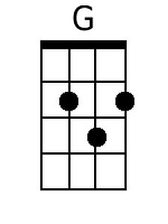
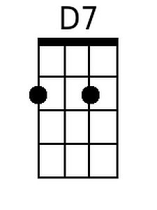
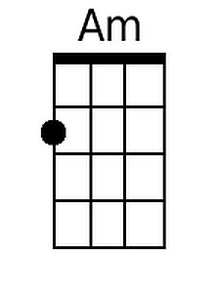

BARITONE

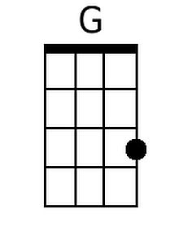

G G7
After all the news to tell him:
C
how you spent your time;
D7 G
and what’s the latest thing the neighbors say;
G G7
and your mother called last Friday;
C
“Sunshine” made her cry;
D7 G G7
and you felt the baby move just yester-day.
(Chorus)
C D7 G
And oh, the time that I can lay this tired
C
old body down
Am D7 G G7
and feel your fingers feather soft u-pon me;
C D7
the kisses that I live for;
G C
the love that lights my way;
Am C D7
the happiness that livin’ with you brings me.

G G7
It’s the sweetest thing I know of,
C
just spending time with you
D7 G
It’s the little things that make a house a home.
G G7 C
Like a fire softly burning and supper on the stove.
D7 G G7
And the light in your eyes that makes me warm.
(Chorus) 2x
D7 C G
I said, hey it’s good to be back home a-gain.

