Be My Baby (Phil Spector, Jeff Barry, Ellie Greenwich)

C Dm G7
C
Dm
G7
F
The night we met I knew I needed you so
C Dm G7
And if I had the chance I'd never let you go.
E7
So won't you say you love me,
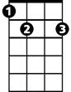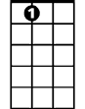A7
E7
Am
A7
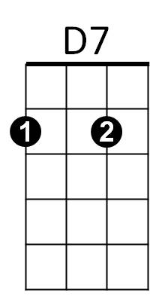
I'll make you so proud of me.
D7 G7
We'll make 'em turn their heads every place we go.
C
So won't you, please,

Chorus:
Be my, be my baby
Am
Be my little baby, my one and only baby
F
Say you'll be my darlin', be my be my baby
G7
Be my baby now, Wha-oh-oh-oh.

C Dm G7
I'll make you happy, baby, just wait and see.
C Dm G7
For every kiss you give me I'll give you three.
E7
Oh, since the day I saw you
A7
I have been waiting for you.
BARITONE
C
Am
E7
D7
F
G7
D7 G7
Dm
You know I will adore you 'til eternity.
C
So won't you, please,

(Chorus)
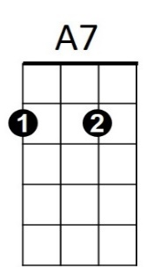
G7 C
So come on and, please,

(Chorus 2x)

