Because (Ron Ryan)

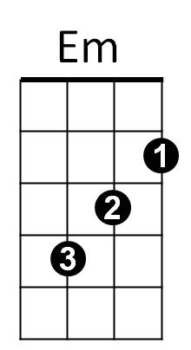
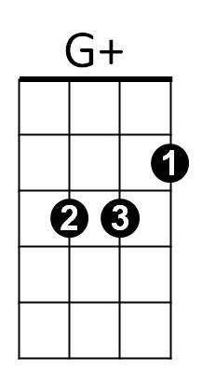


Intro: G G+ C Cm / G Am D7 G D7
G
G7

G G+ Em G7
It’s right that I should care about you
Am D Bb+
And try to make you happy when you’re blue
G G+ C Cm


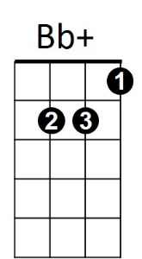

It’s right, it’s right, to feel the way I do
C
D
Am
G Am D7 G
Because, because I love you

Bridge:

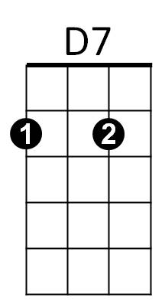
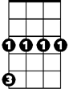
Am D7 G Em
Cm
It’s wrong to say I don’t think of you
Am D7 Am D D7
‘Cause when you say these things, you know it makes me blue

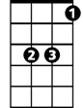
G G+ Em G7
Eb
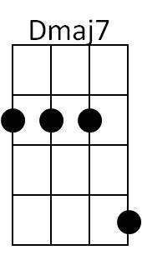
Give me one kiss and I’ll be happy
Am D Bb+
Just, just to be with you
G G+ C Cm
Give me, give me, a chance to be near you,
G Am D7 G Eb Dmaj7
Because, because I love you

Instrumental verse

D7

G G+ Em G7
Give me one kiss and I’ll be happy
Am D Bb+
Just, just to be with you
G G+ C Cm
Give me, give me, a chance to be near you,
G Am D7 G Em
Because, because I love you
Am D7 G
Because, because I love you

