Beep Beep (Little Nash Rambler) (Carl Cicchetti & Donald Claps) (G)

G D7 G D7 G D7 G  While riding in my Cadillac, what to my surprise.  G D7 G D7  A little Nash Rambler was following me,  G D7 G  About one third my size.  Cm G  The guy must have wanted to pass me up,  Cm G  As he kept on tooting his horn.  G D7 G D7 G D7 G  I'll show him that a Cadillac is not a car to scorn.  Chorus  G D7  Beep-beep, beep-beep..  G D7 G  His horn went beep, beep, beep.  G D7 G D7  I pushed my foot down to the floor,  G D7 G  To give the guy the shake.  G D7 G D7  But the little Nash Rambler stayed right be-hind.  G D7 G  He still l had on his brake.  G Cm G  He musta thought his car had more guts,  Cm G  As he kept on tooting his horn.  G D7 G D7 G D7 G  I'll show him that a Cadillac is not a car to scorn. Chorus  G D7 G D7  My car went into passing gear  G D7 G  And we took off with gust.  D7 G  Soon we were going ninety,  D7 G  Musta left him in the dust. |  |  |  | Cm G  When I peeked in the mirror of my car  Cm G  I couldn't believe my eyes.  D7 G D7  The little Nash Rambler was right behind,  G D7 G  You'd think that guy could fly. Chorus  G D7 G D7  Now we were doing a hundred and ten,  G D7 G  This certainly was a race.  D7 G  For a Rambler to pass a Caddy,  D7 G  Would be a big disgrace.  Cm G  The guy must have wanted to pass me up,  Cm G  As he kept on tooting his horn.  G D7 G D7 G D7 G  I'll show him that a Cadillac is not a car to scorn.  G D7 G D7  Now we're going a hundred and twenty,  G D7 G  As fast as I could go.  G D7 G D7  The Rambler pulled along side of me  G D7 G  As if we were going slow.  Cm G  The fella rolled down his window  Cm G  And yelled for me to hear..  Cm G  'Hey buddy how do I get this car,  D7 C D7 G  Outa sec..ond gear?'
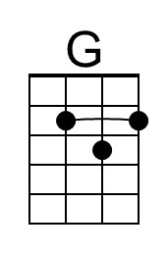 | 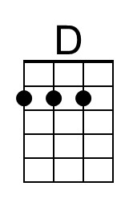 | 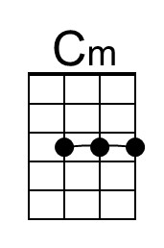 |  | Bari | 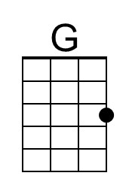 | 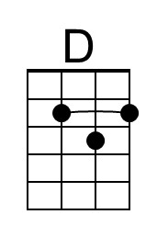 | 