Being A Pirate (Don Freed, Tom Lewis)

C G
Being a pirate is all fun and games, till somebody loses an ear.
G
It drips down your neck, and it falls on the deck,
NC C
Till someone shouts out: "Hey, what's this 'ere?"
Am
You can't wear your glasses you don't attract lasses.
C C7 F
And folks have to shout so you'll hear.
C G C
Being a pirate is all fun and games till somebody loses an ear.

Chorus
F C
But its all part of being a pirate!
G C
You can't be a pirate, with all of your parts;
F C
It’s all part of being a pirate!
G C F C F C F G
You can't be a pirate, with all of your parts.

C G
Being a pirate is all fun and games, till somebody loses a hand.
G
It spurts and it squirts and it bloody well hurts,
C
Pain only a pirate can stand.
Am
A nice metal hook is a fash'nable look,
C C7 F
But then you can't play in the band;
C G C
Being a pirate is all fun and games till somebody loses an hand. Chorus

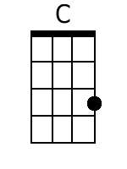 | 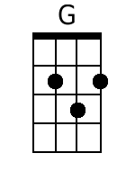 | 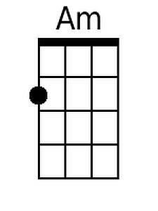 | 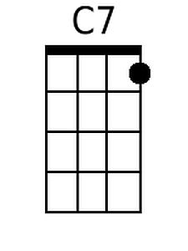 | 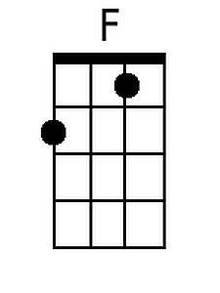
Baritone
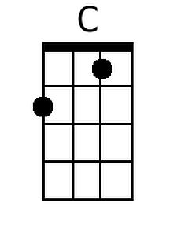 | 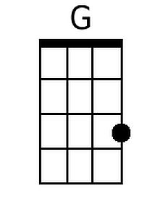 | 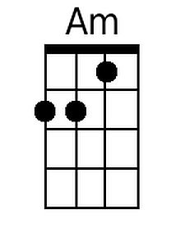 | 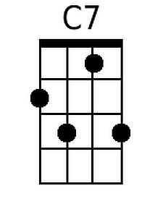 | 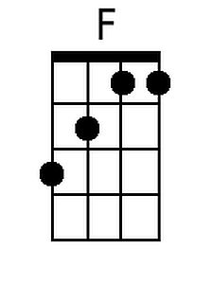

Being A Pirate – Page 2

C G
Being a pirate is all fun and games, till somebody loses an eye.
G
It stings like the blazes. It makes you pull faces,
C
You can't let your mates see you cry.
Am
Well, a dashing black patch, will cover the hatch
C C7 F
And make sure your socket stays dry.
C G C
Being a pirate is all fun and games till somebody loses an eye. Chorus

C G
Being a pirate is all fun and games, till somebody loses a leg.
G C
It hurts like the dickens-your pace never quickens-hopping around on a
peg.
Am
Ask your sweetheart to marry, but too long you've tarried,
C C7 F
And now you can't kneel down and beg.
C G C
Being a pirate is all fun and games till somebody loses a leg. Chorus

C G
Being a pirate is all fun and games, till somebody loses a whatsit.
G
You didn't choose it but you still hate to lose it
C
and you're hoping that somebody spots it.
Am
Then the Doc comes along and he sews it back on;
C C7 F
Or he ties it up tight and he knots it!
C G C
Being a pirate is all fun and games till somebody loses a whatsit! Chorus

Outro
F C
Its all part of being a pirate!
G C F C F C F G C
You can't be a pirate, with all of your parts.

