Bitter Green (Gordon Lightfoot) Key C




Intro: C F G F G C G7 (Melody for last 2 lines of chorus)
F
G
C

C G
Upon the bitter green she walked, the hills above the town,
Em Dm
Echoed to her footsteps as soft as Eider down.
Em Dm
Waiting for her master to kiss away her tears,


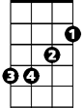
G7
Dm
G7
Em
Waiting through the years.

CHORUS:
C F G
Bitter Green they called her, walking in the sun,
F G C G7
Loving everyone that she met.
C F G
BARITONE

Bitter Green they called her, waiting in the sun,
C
G
F
F G C G7
Waiting for someone to take her home.

C G
Some say he was a sailor who died away at sea,
Em Dm



Some say he was a prisoner who never was set free.
Em
G7
Dm
Em Dm
Lost upon the ocean he died there in the mist,
G7
Dreaming of her kiss.

(CHORUS)

C G
But now the bitter green is gone, the hills have turned to rust,
Em Dm
There comes a weary stranger, his tears fall in the dust,
Em Dm
Kneeling by the churchyard in the autumn mist,
G7
Dreaming of a kiss.

(CHORUS)

F G C
Waiting for someone to take her home.

Bitter Green (Gordon Lightfoot) Key D
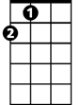

Intro: D G A G A D A7 (Melody for last 2 lines of chorus)
A
G
D

D A
Upon the bitter green she walked, the hills above the town,
F#m Em
Echoed to her footsteps as soft as Eider down.
F#m Em
Waiting for her master to kiss away her tears,
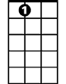
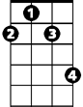
A7
A7
F#m
Em
Waiting through the years.

CHORUS:
D G A
Bitter Green they called her, walking in the sun,
G A D A7
Loving everyone that she met.
D G A
Bitter Green they called her, waiting in the sun,
BARITONE
G A D A7
A
G
D
Waiting for someone to take her home.

D A
Some say he was a sailor who died away at sea,
F#m Em
Some say he was a prisoner who never was set free.
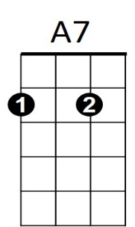
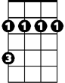
F#m Em
Em
F#m
Lost upon the ocean he died there in the mist,
A7
Dreaming of her kiss.

(CHORUS)

D A
But now the bitter green is gone, the hills have turned to rust,
F#m Em
There comes a weary stranger, his tears fall in the dust,
F#m Em
Kneeling by the churchyard in the autumn mist,
A7
Dreaming of a kiss.

(CHORUS)

G A D
Waiting for someone to take her home.

Bitter Green (Gordon Lightfoot) Key G
Intro: G C D C D G D7 (Melody for last 2 lines of chorus)
G
D
C

G D
Upon the bitter green she walked, the hills above the town,
Bm Am
Echoed to her footsteps as soft as Eider down.
Bm Am
Waiting for her master to kiss away her tears,
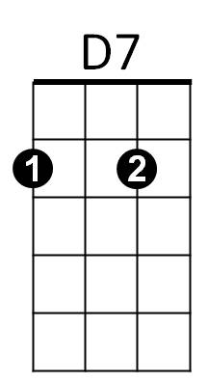
D7
Bm
Am
Waiting through the years.

CHORUS:
G C D
Bitter Green they called her, walking in the sun,
C D G D7
Loving everyone that she met.
G C D
Bitter Green they called her, waiting in the sun,
BARITONE
C D G D7
G
D
C
Waiting for someone to take her home.

G D
Some say he was a sailor who died away at sea,
Bm Am
Some say he was a prisoner who never was set free.
D7
Am
Bm
Bm Am
Lost upon the ocean he died there in the mist,
D7
Dreaming of her kiss.

(CHORUS)

G D
But now the bitter green is gone, the hills have turned to rust,
Bm Am
There comes a weary stranger, his tears fall in the dust,
Bm Am
Kneeling by the churchyard in the autumn mist,
D7
Dreaming of a kiss.

(CHORUS)

C D G
Waiting for someone to take her home.

