Black Velvet Band (Traditional, Adapted by Will Millar)
Key of C; 12/8 Time, a quick-time variant of ¾ time.
Black Velvet Band, The Irish Rovers (45 rpm version, 1967)

Intro (Last Two Lines of Chorus): C Am Dm G C  Chorus:  C  Her eyes they shone like the diamonds.  C D G  You'd think she was Queen of the Land.  C Am  And her hair hung over her shoulders,  Dm G C  Tied up with a Black Velvet Band.  C  1. In a neat little town they call Belfast,  C Dm G  Ap-prenticed to trade I was bound.  C Am  And many’s an hour sweet happiness,  Dm G C  I spent in that neat little town.  C  Till bad misfortune came o’er me  C Dm G  That caused me to stray from the land.  C Am  Far a-way from me friends and re-lations  Dm G C  To follow the Black Velvet Band. Chorus.  C  2. Well, I was out strolling one evening,  C Dm G  Not meaning to go very far.  C Am  When I met with a frolicsome damsel  Dm G C  A-selling her trade in the bar.  C  When a watch she took from a customer,  C Dm G  And slipped it right into my hand.  C Am  Then the law came and put me in prison,  Dm G C  Bad luck to her Black Velvet Band. Chorus. | 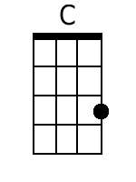 | 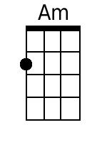
 | 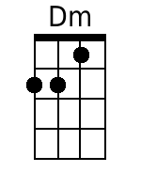 | 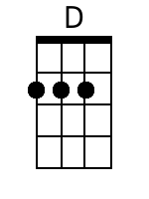
 | 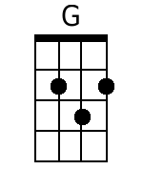
 | Bari | 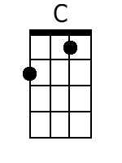
 | 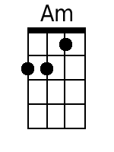 | 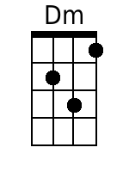
 | 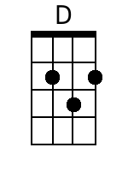 | 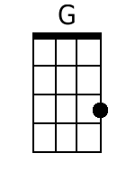
Black Velvet Band - Irish Rovers - C - 2 of 2
C
3. Next mornin' before judge and jury,
C Dm G
Her trial I had to ap-pear.
C Am
And the judge he says, 'Me young fellow,
Dm G C
The case against you is quite clear.
C
And seven long years is your sentence,
C G
You're going to Van Diemen’s Land.*
C Am
Far a-way from your friends and re-lations
Dm G C
To follow the Black Velvet Band.' Chorus.

C
4. So, come all ye jolly young fellows,
C Dm G
I'll have you take warnin' by me.
C Am
And when-ever you're into the liquor, me lads,
Dm G C
Be-ware of the pretty Colleen.
C
For they'll fill you with whiskey and porter,
C Dm G
Til you are not able to stand.
C Am
And the very next thing that you know, me lads,
Dm G C
You've landed in Van Diemen’s Land. Chorus (2x)

*Van Diemen’s Land was a former name for the island of Tasmania, which was one of several British penal colonies in the south Pacific from 1803 until 1856, when the island’s penal colonies were abolished and it was renamed Tasmania. It has been a part of the Commonwealth of Australia since 1901.

In other recordings by the Irish Rovers, the lyrics are slightly changed. Compare:
- Black Velvet Band (the original from the LP “The Unicorn,” 1967)
- Black Velvet Band (from “40 Years A-Rovin’)
- Black Velvet Band (from “50 Years – Vol. 1,” 2014)
- Black Velvet Band (from “50th Anniversary Live on St. Patrick’s Day,” 2016)
In some performances by the Irish Rovers, there is a key change before the 4th verse, presumably up to the next key. For more information, see: Black Velvet Band, Wikipedia.

Black Velvet Band (Traditional, Adapted by Will Millar)
Key of G; 12/8 Time, a quick-time variant of ¾ time.
Black Velvet Band, The Irish Rovers (45 rpm version, 1967)

Intro (Last Two Lines of Chorus): G Em Am D G  Chorus:  G  Her eyes they shone like the diamonds.  G A D  You'd think she was Queen of the Land.  G Em  And her hair hung over her shoulders,  Am D G  Tied up with a Black Velvet Band.  G  1. In a neat little town they call Belfast,  G Am D  Ap-prenticed to trade I was bound.  G Em  And many’s an hour sweet happiness,  Am D G  I spent in that neat little town.  G  Till bad misfortune came o’er me  G Am D  That caused me to stray from the land.  G Em  Far a-way from me friends and re-lations  Am D G  To follow the Black Velvet Band. Chorus.  G  2. Well, I was out strolling one evening,  G Am D  Not meaning to go very far.  G Em  When I met with a frolicsome damsel  Am D G  A-selling her trade in the bar.  G  When a watch she took from a customer,  G Am D  And slipped it right into my hand.  G Em  Then the law came and put me in prison,  Am D G  Bad luck to her Black Velvet Band. Chorus. |  | 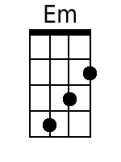
 | 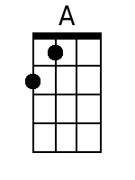
 | Bari
 | 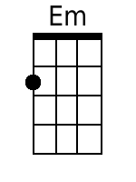
 |  | 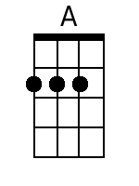
Black Velvet Band - Irish Rovers - G - 2 of 2
G
3. Next mornin' before judge and jury,
G Am D
Her trial I had to ap-pear.
G Em
And the judge he says, 'Me young fellow,
Am D G
The case against you is quite clear.
G
And seven long years is your sentence,
G D
You're going to Van Diemen’s Land.*
G Em
Far a-way from your friends and re-lations
Am D G
To follow the Black Velvet Band.' Chorus.

G
4. So, come all ye jolly young fellows,
G Am D
I'll have you take warnin' by me.
G Em
And when-ever you're into the liquor, me lads,
Am D G
Be-ware of the pretty Colleen.
G
For they'll fill you with whiskey and porter,
G Am D
Til you are not able to stand.
G Em
And the very next thing that you know, me lads,
Am D G
You've landed in Van Diemen’s Land. Chorus (2x)

*Van Diemen’s Land was a former name for the island of Tasmania, which was one of several British penal colonies in the south Pacific from 1803 until 1856, when the island’s penal colonies were abolished and it was renamed Tasmania. It has been a part of the Commonwealth of Australia since 1901.

In other recordings by the Irish Rovers, the lyrics are slightly changed. Compare:
- Black Velvet Band (the original from the LP “The Unicorn,” 1967)
- Black Velvet Band (from “40 Years A-Rovin’)
- Black Velvet Band (from “50 Years – Vol. 1,” 2014)
- Black Velvet Band (from “50th Anniversary Live on St. Patrick’s Day,” 2016)
In some performances by the Irish Rovers, there is a key change before the 4th verse, presumably up to the next key. For more information, see: Black Velvet Band, Wikipedia.

