Blowin’ in the Wind (Bob Dylan)

Intro: Chords for last line of verse

C F C Am C F C
How many roads must a man walk down before you call him a man?
C F C Am C F G
How many seas must a white dove sail before she can sleep in the sand?
C F C Am C F G
How many times must the cannon balls fly before they are forever banned?
F G C Am
The answer my friend, is blowin' in the wind.
F G C
The answer is blowin' in the wind.

C F C Am C F C
How many years can a mountain exist, before it's washed to the sea?
C F C Am C F G
How many years can some people exist, before they're allowed to be free?
C F C Am C F G
How many times can a man turn his head and pretend that he just doesn't see?
F G C Am
The answer my friend, is blowin' in the wind.
F G C
The answer is blowin' in the wind.

C F C Am C F C
How many times must a man look up before he can see the sky?
C F C Am C F G
How many ears must one man have before he can hear people cry?
C F C Am C F G
How many deaths will it take till he knows that too many people have died?
F G C Am
The answer my friend, is blowin' in the wind.
F G C
The answer is blowin' in the wind.
F G C
The answer is blowin' in the wind
BARITONE
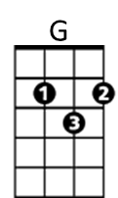
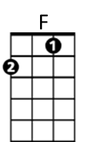
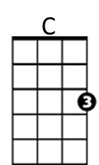

Am
G
C
F
Am

