Blue Bayou (Roy Orbison & Joe Melson, 1961) (C) Tempo: 95 bpm
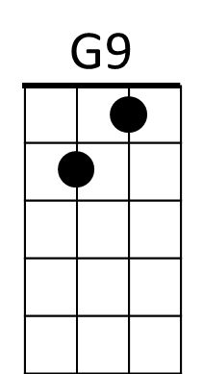
Intro: C | G7 | C

C Cmaj7 Am7
I feel so bad, I’ve got a worried mind -
G7 G9
I'm so lonesome all the time,
G7 G9 C
Since I left my baby behind on Blue Bayou.

C Cmaj7 Am7 G7
Saving nickels, saving dimes;
G9
Working till the sun don't shine;
G7 G9 C
Looking forward to happier times on Blue Bayou.
Bb C

C Cmaj7
I'm going back someday,
C Cmaj7 G7
Come what may to Blue Bayou.
Where the folks are fine
C
And the world is mine on Blue Bayou.
Where those fishing boats
C7
With their sails a-float,
F Fm
If I could only see,
C G7
That fa-miliar sunrise through sleepy eyes
C
How happy I'd be.

C Cmaj7 Am7
Gonna see my baby again,
G7 G9
Gonna be with some of my friends;
G7 G9 C
Maybe I'll feel better again on Blue Bayou.

C Cmaj7 Am7 G7
Saving nickels, saving dimes;
G9
Working till the sun don't shine;
G7 G9 C
Looking forward to happier times on Blue Bayou.
Bb C

C Cmaj7
I'm going back someday,
C Cmaj7 G7
Come what may to Blue Bayou.
Where you sleep all day
C
And the catfish play on Blue Bayou.
Where those fishing boats
C7
With their sails a-float,
F Fm
If I could only see,
C G7
That fa-miliar sunrise through sleepy eyes
C
How happy I'd be.

C Cmaj7 Am7
Gonna see my baby again,
G7 G9
And to be with some of my friends;
G7 G9 C
Maybe I’d be happy then on Blue Bayou.
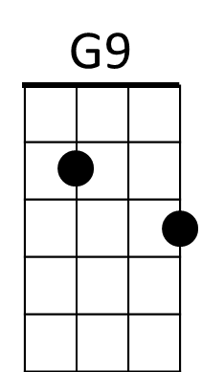
C Cmaj7
I'm going back someday,
C Cmaj7 G7
Gonna stay on Blue Bayou.
Where the folks are fine
C
And the world is mine on Blue Bayou.
C C7
Oh that (boy/gal) of mine by my side,
F Fm
The silver moon and the evening tide,
C G7
Oh some sweet day, gonna take away
C
This hurting inside.
G7 G9 G7
Well I'll never be blue, my dreams come true,
F G7 C C (3 measures, end C)
On Blue - Ba - you.

