Blue Eyes Crying In The Rain (Fred Rose) Key C
Intro: G G7 C (melody for last line of verse)
C
In the twilight glow I see her
G G7 C
Blue eyes crying in the rain
C
When we kissed good-bye and parted
G7 C C7





I knew we'd never meet again
F
C7
C
G
G7

F
Love is like a dying ember
C G7
Only memories remain
C
Through the ages I'll remember
G G7 C
Blue eyes crying in the rain

C
Now my hair has turned to silver
G7 C
All my life I've love in vain
C
I can see her star in heaven
G G7 C C7
Blue eyes crying in the rain

F
Someday when we meet up yonder
C G7
We'll stroll hand in hand again
BARITONE

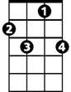
C
G
F
G7
C7
C
In the land that knows no parting
G G7 C
Blue eyes crying in the rain
G G7 C F C
Blue eyes crying in the rain

Blue Eyes Crying In The Rain (Fred Rose) Key D
Intro: A A7 D (melody for last line of verse)
D
In the twilight glow I see her
A A7 D
Blue eyes crying in the rain
D
As when we kissed good-bye and parted
A7 D D7
I knew we'd never meet again

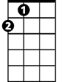
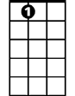
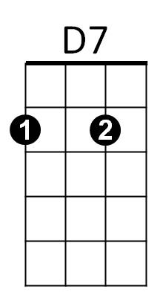
G
D
A
A7
G
Love is like a dying ember
D A7
Only memories remain
D
Through the ages I'll remember
A A7 D
Blue eyes crying in the rain

D
Now my hair has turned to silver
A7 D
All my life I've love in vain
D
I can see her star in heaven
A A7 D D7
Blue eyes crying in the rain

G
Someday when we meet up yonder
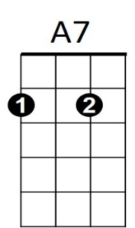
D A7
A
D7
D
BARITONE
G
We'll stroll hand in hand again
D
In the land that knows no parting
A A7 D
Blue eyes crying in the rain
A A7 D G D
Blue eyes crying in the rain

Blue Eyes Crying In The Rain (Fred Rose) Key G
Intro: D D7 G (melody for last line of verse)
G
In the twilight glow I see her
D D7 G
Blue eyes crying in the rain
G
As when we kissed good-bye and parted
D7 G G7
I knew we'd never meet again
C
G7
D
G

C
Love is like a dying ember
G D7
Only memories remain
G
Through the ages I'll remember
D D7 G
Blue eyes crying in the rain

G
Now my hair has turned to silver
D7 G
All my life I've love in vain
G
I can see her star in heaven
D D7 G G7
Blue eyes crying in the rain

C
Someday when we meet up yonder
G D7
G
D
G7
C
BARITONE
D7
We'll stroll hand in hand again
G
In the land that knows no parting
D D7 G
Blue eyes crying in the rain
D D7 G C G
Blue eyes crying in the rain

