Blue Hawaii (Leo Rabin / Ralph Rainger) Key C
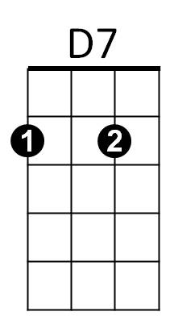


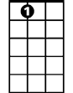
INTRO: A7 D7 G7 C Fm C
G7
C
A7
C F C
Night and you and Blue Hawaii
A7 D7 G7
The night is hea venly

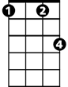


C G7
C7
Fm
G
F
And you are heaven to me

C F C
Lovely you and Blue Hawaii
A7 D7 G7
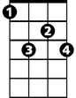
With all this loveliness
G# 7
C F C C7
There should be l – o - ve

Chorus:
F C
Come with me – whi-le the moon is on the sea
D7 G G7 G#7 G7
The night is young and so are we, so are we

C F C
BARITONE
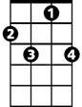

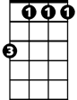
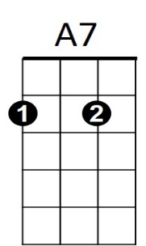
Dreams come true in Blue Hawaii
C7
F
C
G7
Fm
D7
A7 D7 G7
And mine could all come true
C F C C7
This magic night of nights with you

(Chorus)
G

C F C
Dreams come true in Blue Hawaii
A7 D7 G7
And mine could all come true
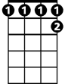
C Fm C (hold)
G#7
This magic night – of nights with you

Blue Hawaii (Leo Rabin / Ralph Rainger) Key G
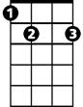
INTRO: E7 A7 D7 G Cm G
E7
A7
G
BARITONE
G C G
Night and you and Blue Hawaii
E7 A7 D7
The night is heavenly
G D7

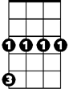
And you are heaven to me
D
G7
C
Cm

G C G
Lovely you and Blue Hawaii
E7 A7 D7
With all this loveliness
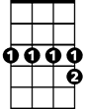
G C G G7
D#7
There should be l – o - ve

Chorus:
C G
Come with me – whi-le the moon is on the sea
A7 D D7 D#7 D7
The night is young and so are we, so are we

G C G
Dreams come true in Blue Hawaii
E7 A7 D7
E7
D7
G
And mine could all come true
G C G G7
This magic night of nights with you

(Chorus)
D
G7
C
Cm
G C G
Dreams come true in Blue Hawaii
E7 A7 D7
And mine could all come true
G Cm G (hold)
This magic night – of nights with you
D#7

