Blue Moon (Lorenz Hart / Richard Rodgers)





C Am F
C7
G7
F
Am
C
Blue moon,
G7 C Am F
You saw me standing alone.
G7 C Am F
Without a drea m in my heart,
G7 C Am F G7

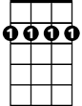
Without a love of my own.
Dm
Bm7
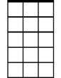
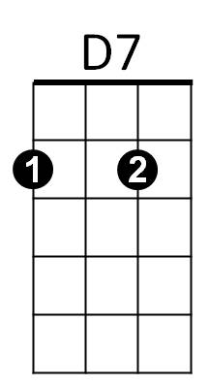
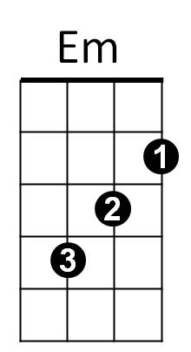
C Am F
Am7
Blue moon,
G7 C Am F
You knew just what I was there for,
G7 C Am F
You heard me saying a prayer for,
G7 C F C C7


Someone I really care for.
Gm
G

Chorus:
Dm G7 C Am
And then there suddenly appeared before me.
Dm G7 C
The only one my heart could ever hold.
Am7 Bm7 Em
I heard s omebody whisper, please adore me.
C D7 G G7
And when I looked, the moon had turned to gold.

C Am F
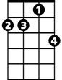
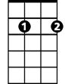

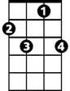
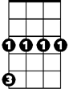
Blue moon,
Dm
BARITONE
Am7
Bm7
D7
C
Am
F
G7
C7
G
Em
Gm
G7 C Am F
Now I'm no longer alone.
G7 C Am F
Without a dream in my heart,
G7 C Am F G7
Without a love of my own.

(Chorus)

C Am F
Blue moon,
G7 C Am F
You saw me standing alone.
G7 C Am F
Without a dream in my heart,
G7 C F C
Without a love of my own.
Gm C
Blue.............Moon

