Blue Spanish Eyes (Charles Singleton, Bert Kaempfert & Eddie Snyder) Key of C

Intro: Chords for ending



C7
C
G7
C
Blue Spanish eyes
G7
Teardrops are falling from your Spanish eyes
Please, please don't cry
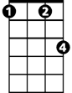

C
Fm
F
This is just adios and not good bye
Soon, I'll return
C7 F
Bringing you all the love your heart can hold
Fm C
Please, say si si
G7 C F C
Say you and your Spanish eyes will wait for me.

C
Blue Spanish eyes
G7
Prettiest eyes in all of Mexico
BARITONE
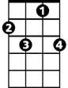
True Spanish eyes
C7
C
G7
C
Please smile for me once more before I go
Soon, I'll return
C7 F
Bringing you all the love your heart can hold
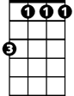

Fm C
Fm
F
Please, say si si
G7 C F C
Say you and your Spanish eyes will wait for me.

ending:

G7 C F C
Say you and your Spanish eyes will wait for me.

Blue Spanish Eyes (Charles Singleton, Bert Kaempfert & Eddie Snyder) Key of G

Intro: Chords for ending
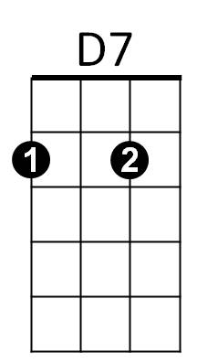

G7
G
G
Blue Spanish eyes
D7
Teardrops are falling from your Spanish eyes
Please, please don't cry
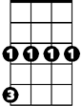
G
Cm
C
This is just adios and not good bye
Soon, I'll return
G7 C
Bringing you all the love your heart can hold
Cm G
Please, say si si
D7 G C G
Say you and your Spanish eyes will wait for me.

G
Blue Spanish eyes
D7
Prettiest eyes in all of Mexico
True Spanish eyes
BARITONE
G
D7
G
G7
Please smile for me once more before I go
Soon, I'll return
G7 C
Bringing you all the love your heart can hold
Cm G
C
Please, say si si
Cm
D7 G C G
Say you and your Spanish eyes will wait for me.

ending:

D7 G C G
Say you and your Spanish eyes will wait for me.

