Blue Velvet (Bernie Wayne & Lee Morris) Key of G
Intro: Chords for first verse


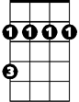

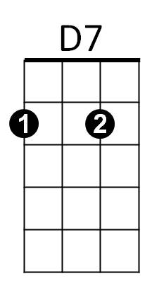
D7 G Bm
Am7
D
Bm
G
She wore blue velvet
Am7 D Gmaj7
Bluer than velvet was the night
Am7 D7
Softer than satin was the light,

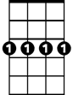
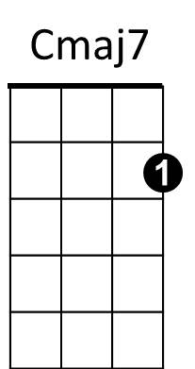
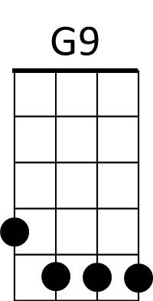
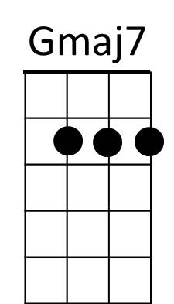
Gmaj7 Am7
G7
Cm7
From the stars.

D7 G Bm
She wore blue ve lvet

Am7 D Gmaj7
Bm7
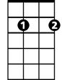
Bluer than Velvet were her eyes,
Em7
Am7 D7
Warmer than May her tender sighs,
G9
Love was ours.

Cmaj7 Cm7
Ours, a love I held tightly,
Gmaj7 G G7
Feeling the rapture grow,
BARITONE
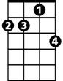
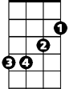

Cmaj7 Cm7
D
Am7
Bm
G
D7
Like a flame burning brightly,
Bm7 Em7
But when she left,
Am7 D7

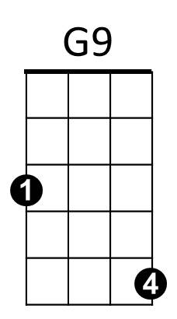
Gone was the glow
G7
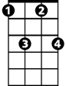
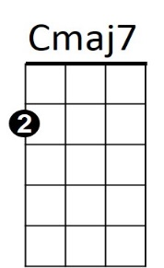
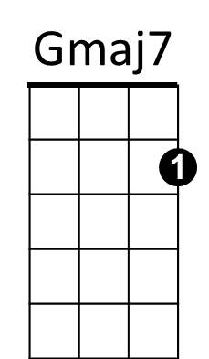
G Bm
Cm7
Of Blue velvet
Am7 D Gmaj7
But in my heart there'll always be,
Am7 D7
Precious and warm, a memory
Em7
Bm7
G9
Through the years
Cmaj7 Cm7
And I still can see blue velvet
D7 G
Through my tears

