Born on the Bayou (John Fogardy, 1968) (A)

Intro: A7 A A A A (4x)  A7 A A7  Now, when I was just a little boy  A A7  Standin' to my Daddy's knee  A  My poppa said, "Son, don't  A7  let the man get you an'  A A7  Do what he done to me"  A7 A  'Cause he'll get you  A7  'Cause he'll get you mama  A7 A A7  And I can remember the Fourth of July  A A7 G D  Runnin' through the backwood, bare  A7  And I can still hear my old  A A7  hound dog barkin'  A A7 G D  Chasin' down a hoodoo there  A7 A A7 G D  Chasin' down a hoodoo there |  |  |  |  | Chorus  A7 A A7 G D  Born on the ba-you  A7 A A7 G D  Born on the ba-you  A7 A A7 G D  Born on the ba-you  A7 A A7  Wish I was back on the bayou  A A7  Rollin' with some Cajun queen  A A7  Wishin' I were a fast freight train  A A7  Just a chooglin' on down to New Orleans.  Chorus  A7 A A7  And I can remember the Fourth of July  A A7 G D  Runnin' through the backwood, bare  A7  And I can still hear my old  A A7  hound dog barkin'  A A7 G D  Chasin' down a hoodoo there  A7 A A7 G D  Chasin' down a hoodoo there. Chorus
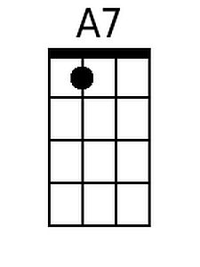 | 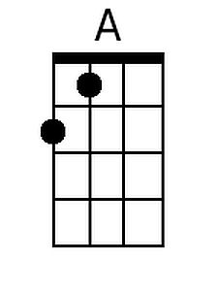 | 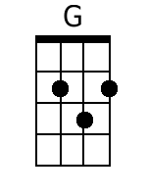 | 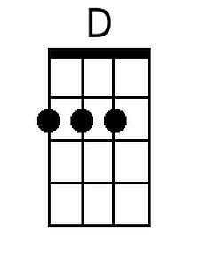 | Bari |  | 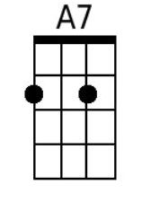 | 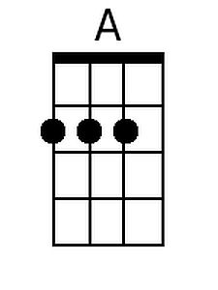 | 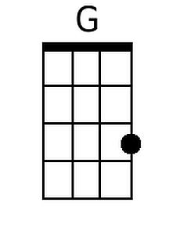 | 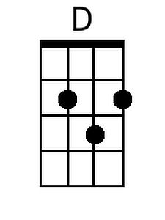

Born on the Bayou (John Fogardy, 1968) (D)

Intro: D7 D D D D (4x)  D7 D D7  Now, when I was just a little boy  D D7  Standin' to my Daddy's knee  D  My poppa said, "Son, don't  D7  let the man get you an'  D D7  Do what he done to me"  D7 D  'Cause he'll get you  D7  'Cause he'll get you mama  D7 D D7  And I can remember the Fourth of July  D D7 C G  Runnin' through the backwood, bare  D7  And I can still hear my old  D D7  hound dog barkin'  D D7 C G  Chasin' down a hoodoo there  D7 D D7 C G  Chasin' down a hoodoo there |  |  |  |  | Chorus  D7 D D7 C G  Born on the ba-you  D7 D D7 C G  Born on the ba-you  D7 D D7 C G  Born on the ba-you  D7 D D7  Wish I was back on the bayou  D D7  Rollin' with some Cajun queen  D D7  Wishin' I were a fast freight train  D D7  Just a chooglin' on down to New Orleans  Chorus  D7 D D7  And I can remember the Fourth of July  D D7 C G  Runnin' through the backwood, bare  D7  And I can still hear my old  D D7  hound dog barkin'  D D7 C G  Chasin' down a hoodoo there  D7 D D7 C G  Chasin' down a hoodoo there Chorus
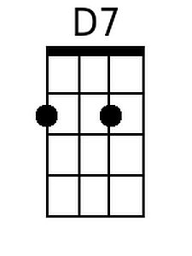 |  | 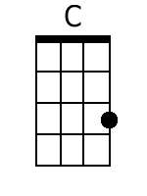 |  | Bari |  | 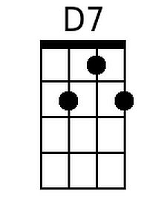 |  | 