Brain Damage (Pink Floyd)

D G7 D G7
The lunatic is on the grass, the lunatic is on the grass
D E7
Remembering games and daisy chains and laughs
A7 D
God to keep the loonies on the path

D G7 D G7
The lunatic is in the hall, the lunatics are in my hall
D E7
The paper holds their folded faces to the floor
A7 D D7
And every day the paperboy brings more

G A
And if the dam breaks open many years too soon
C G
And if there is no room upon the hill
A7
And if your head explodes with dark forbodings too
C G F#m Em A
I’ll see you on the dark side of the moon

D G7 D G7
The lunatic is in my head, the lunatic is in my head
D E7
You raise the blade, you make the change
A7 D
You re-arrange me till I’m same
D E7
You lock the door and throw away the key
A7 D D7
There’s someone in my head but it’s not me
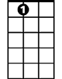
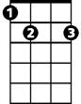


A7
E7
G7
D

BARITONE


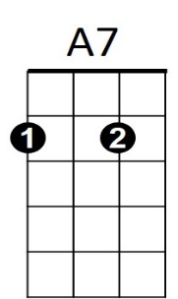

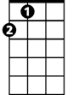
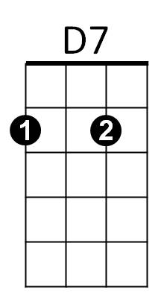

G7
C
D
A
G
C

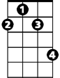
F#m

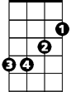
D7
G
Bb
Em

G A
And if the cloud bursts thunder in your ear
C G
You shout and no one seems to hear
A7
And if the band you’re in starts playing different tunes
C G F#m Em A
I’ll see you on the dark side of the moon

(Instrumental)

D D7
All that you touch, and all that you see
Bb A
All that you taste – all you feel
D D7
And all that you love and all that you hate
Bb A
All that you mistrust – all you save
D D7
And all that you give and all that you deal
Bb A
And all that you buy, beg borrow or steal
D D7
And all you create and all you destroy
Bb A
And all that you do and all that you say
D D7
And all that you eat, and everyone you meet
Bb A
And all that you slight and everyone you fight
D D7
And all that is now and all that is gone
Bb A
And all that’s to come and everting under
D D7 Bb D
the sun is in tune but the sun is eclipsed by the mo-on

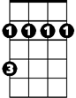

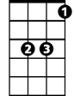
A
F#m
Em
Bb
E7

