 Bus Stop (Graham Gouldman)
Dm
G
Am
Intro: Dm G (x2)
Dm Am Dm Am
Bus stop, wet day, she's there, I say
Dm Am Dm Am
Please share my umbrella
Dm Am Dm Am
Bus stop, bus goes, she stays, love grows
Dm Am Dm Am
Bb
A7
F
Under my umbrella
F G Dm
All that summer we enjoyed it
Bb A7
Wind and rain and shine
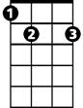Dm Am Dm Am
E7
A
Gm
That umbrella, we employed it
Dm Am Dm
By August she was mine

Chorus:
F E7 Am G F
Every morning I would see her waiting at the stop
Gm E7 A
Sometimes she shopped and she would show me what she bought
F E7 Am G F
Other people stared as if we were both quite insane
G E7 A
Someday my name and hers are going to be the same
BARITONE
Dm Am Dm Am
G
F
Am
That's the way the whole thing started
Dm Am Dm Am
Silly but it's true
Dm Am Dm Am
Thinkin' of a sweet romance
Dm Am Dm Am
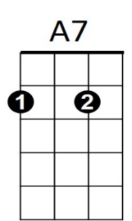
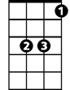Beginning in a queue
Dm
Bb
F G Dm
Came the sun the ice was melting
Bb A7
No more sheltering now
Dm Am Dm Am
Nice to think that that umbrella
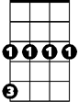Dm Am Dm
E7
A
Gm
Led me to a vow

(Chorus)

(Repeat song through chorus)

Dm Am Dm Am (fade)

