By the Light of the Silvery Moon (Edward Madden / Gus Edwards)

Chorus:
C F A7 D7
By the light of the silvery moon
G7
I want to spoon
C A G7
To my honey I'll croon love's tune
C F A7 D7
Honey moon, keep a-shinin' in June
C F C
Your silvery beams will bring love's dreams
C A7 D7 G7 C G7
We'll be cuddlin' soon - By the silvery moon

C A7 D7 G7
Place - park, scene - dark
C G7
Silvery moon is shining through the trees
Dm G7 Dm
Cast - two, me - you
G7 C
Summer kisses floating on the breeze
C A7 D7 G7
Act one, be - gun
C G7
Dialog - where would ya like to spoon?
F Dm C
My cue, with you
D D7 G G7
Underneath the silvery moon

(CHORUS)
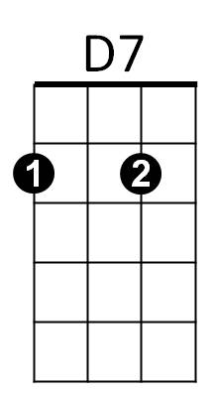
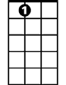


A7
F
C


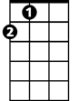


G7
A
Dm
D

C A7 D7 G7
Act - two, Scene - new
C G7
Roses blooming all around the place
Dm G7 Dm
Cast - three, You - me
G7 C
Preacher with a solemn-looking face
C A7 D7 G7
Choir sings, bell rings
C G7
Preacher: You are wed forever more
F Dm C
Act two, all though
D D7 G G7
Every night the same encore

C
By the light, (not the dark but the light)
F A7 D7
Of the silvery moon, (not the sun but the moon)
G7 Dm G7
I want to spoon, (not croon, but spoon)
C A G7
To my honey I'll croon love's tune
C
Honeymoon, (honey moon, honey moon)
F A7 D7
Keep a-shinin' in June
C F C
Your silvery beams will bring love's dreams
C A7 D7 G7 C
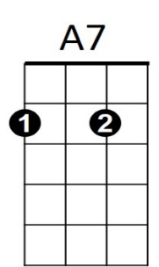




We'll be cuddlin' soon - By the silvery moon
C
F
G7
A
Dm
D
D7
BARITONE

